|  |
| --- |
|  |



|  |  |
| --- | --- |
| Name | Muhammad Taha Jamal |
| Registration Id | 2112244 |
| Section | BSCS 8th A |
| Course | Introduction to DevOps |
| Instructor | Tariq Khan Ghouri |



Lab 03 (Modules 04 and 05)



Parametrize lab02 Terraform configura6on



Tariq Khan Ghouri



IT



INFRASTRUCTURE, CLOU



D AND DEVOPS PROFESS



IONAL



**Instructions:**

1. Log in to Azure Portal with your credentials.
2. Paste all screenshots (highlighted in red) in a single Word document in the correct order.
3. Name the document as YourName-lab03.

**Lab Objectives:**

There are 5 sections in this lab. Each section has a different set of objectives:

* **Section 1:** Parametrize lab02 Terraform configuration.
* **Section 2:** Expand the parametrized Terraform configuration from Section 1 and add a Linux virtual machine to the landscape.
* **Section 3:** Expand Section 2 and define and consume local values.
* **Section 4:** Expand Section 3 and define output blocks.
* **Section 5:** Expand Section 4 and add explicit lifecycle rules and dependencies.

# Section 1

**Objectives:**

* Move resource values to a separate file as variable blocks.
* Update main Terraform file to use variables.
* Validate, deploy, expand, analyze, and destroy infrastructure.

## Part 1: Prepare for the Lab

1. Open a Command Prompt or PowerShell window.
2. Create a directory called lab03s1 in your home directory.
3. Copy lab02.‘ file into lab03s1 directory.
4. Change into the lab03s1 directory.
5. Rename lab02.‘ as lab03s1.‘.
6. Create an empty file called vars03s1.‘.
7. Create an empty file called providers.‘.

## Part 2: Update vars03s1.A File

1. Copy provider and Terraform blocks from lab03s1.‘ to providers.‘ (use a text editor like Notepad or VS Code).
2. Open vars03s1.‘ in a text editor and define variable blocks as follows. Enclose values in double quotation marks:
   1. One block for resource group name.
   2. One block for location.
   3. One block for virtual network name.
   4. One block for virtual network address space.
   5. Two blocks for subnet names (one per subnet).
   6. Two blocks for subnet address spaces (one per address space).
   7. 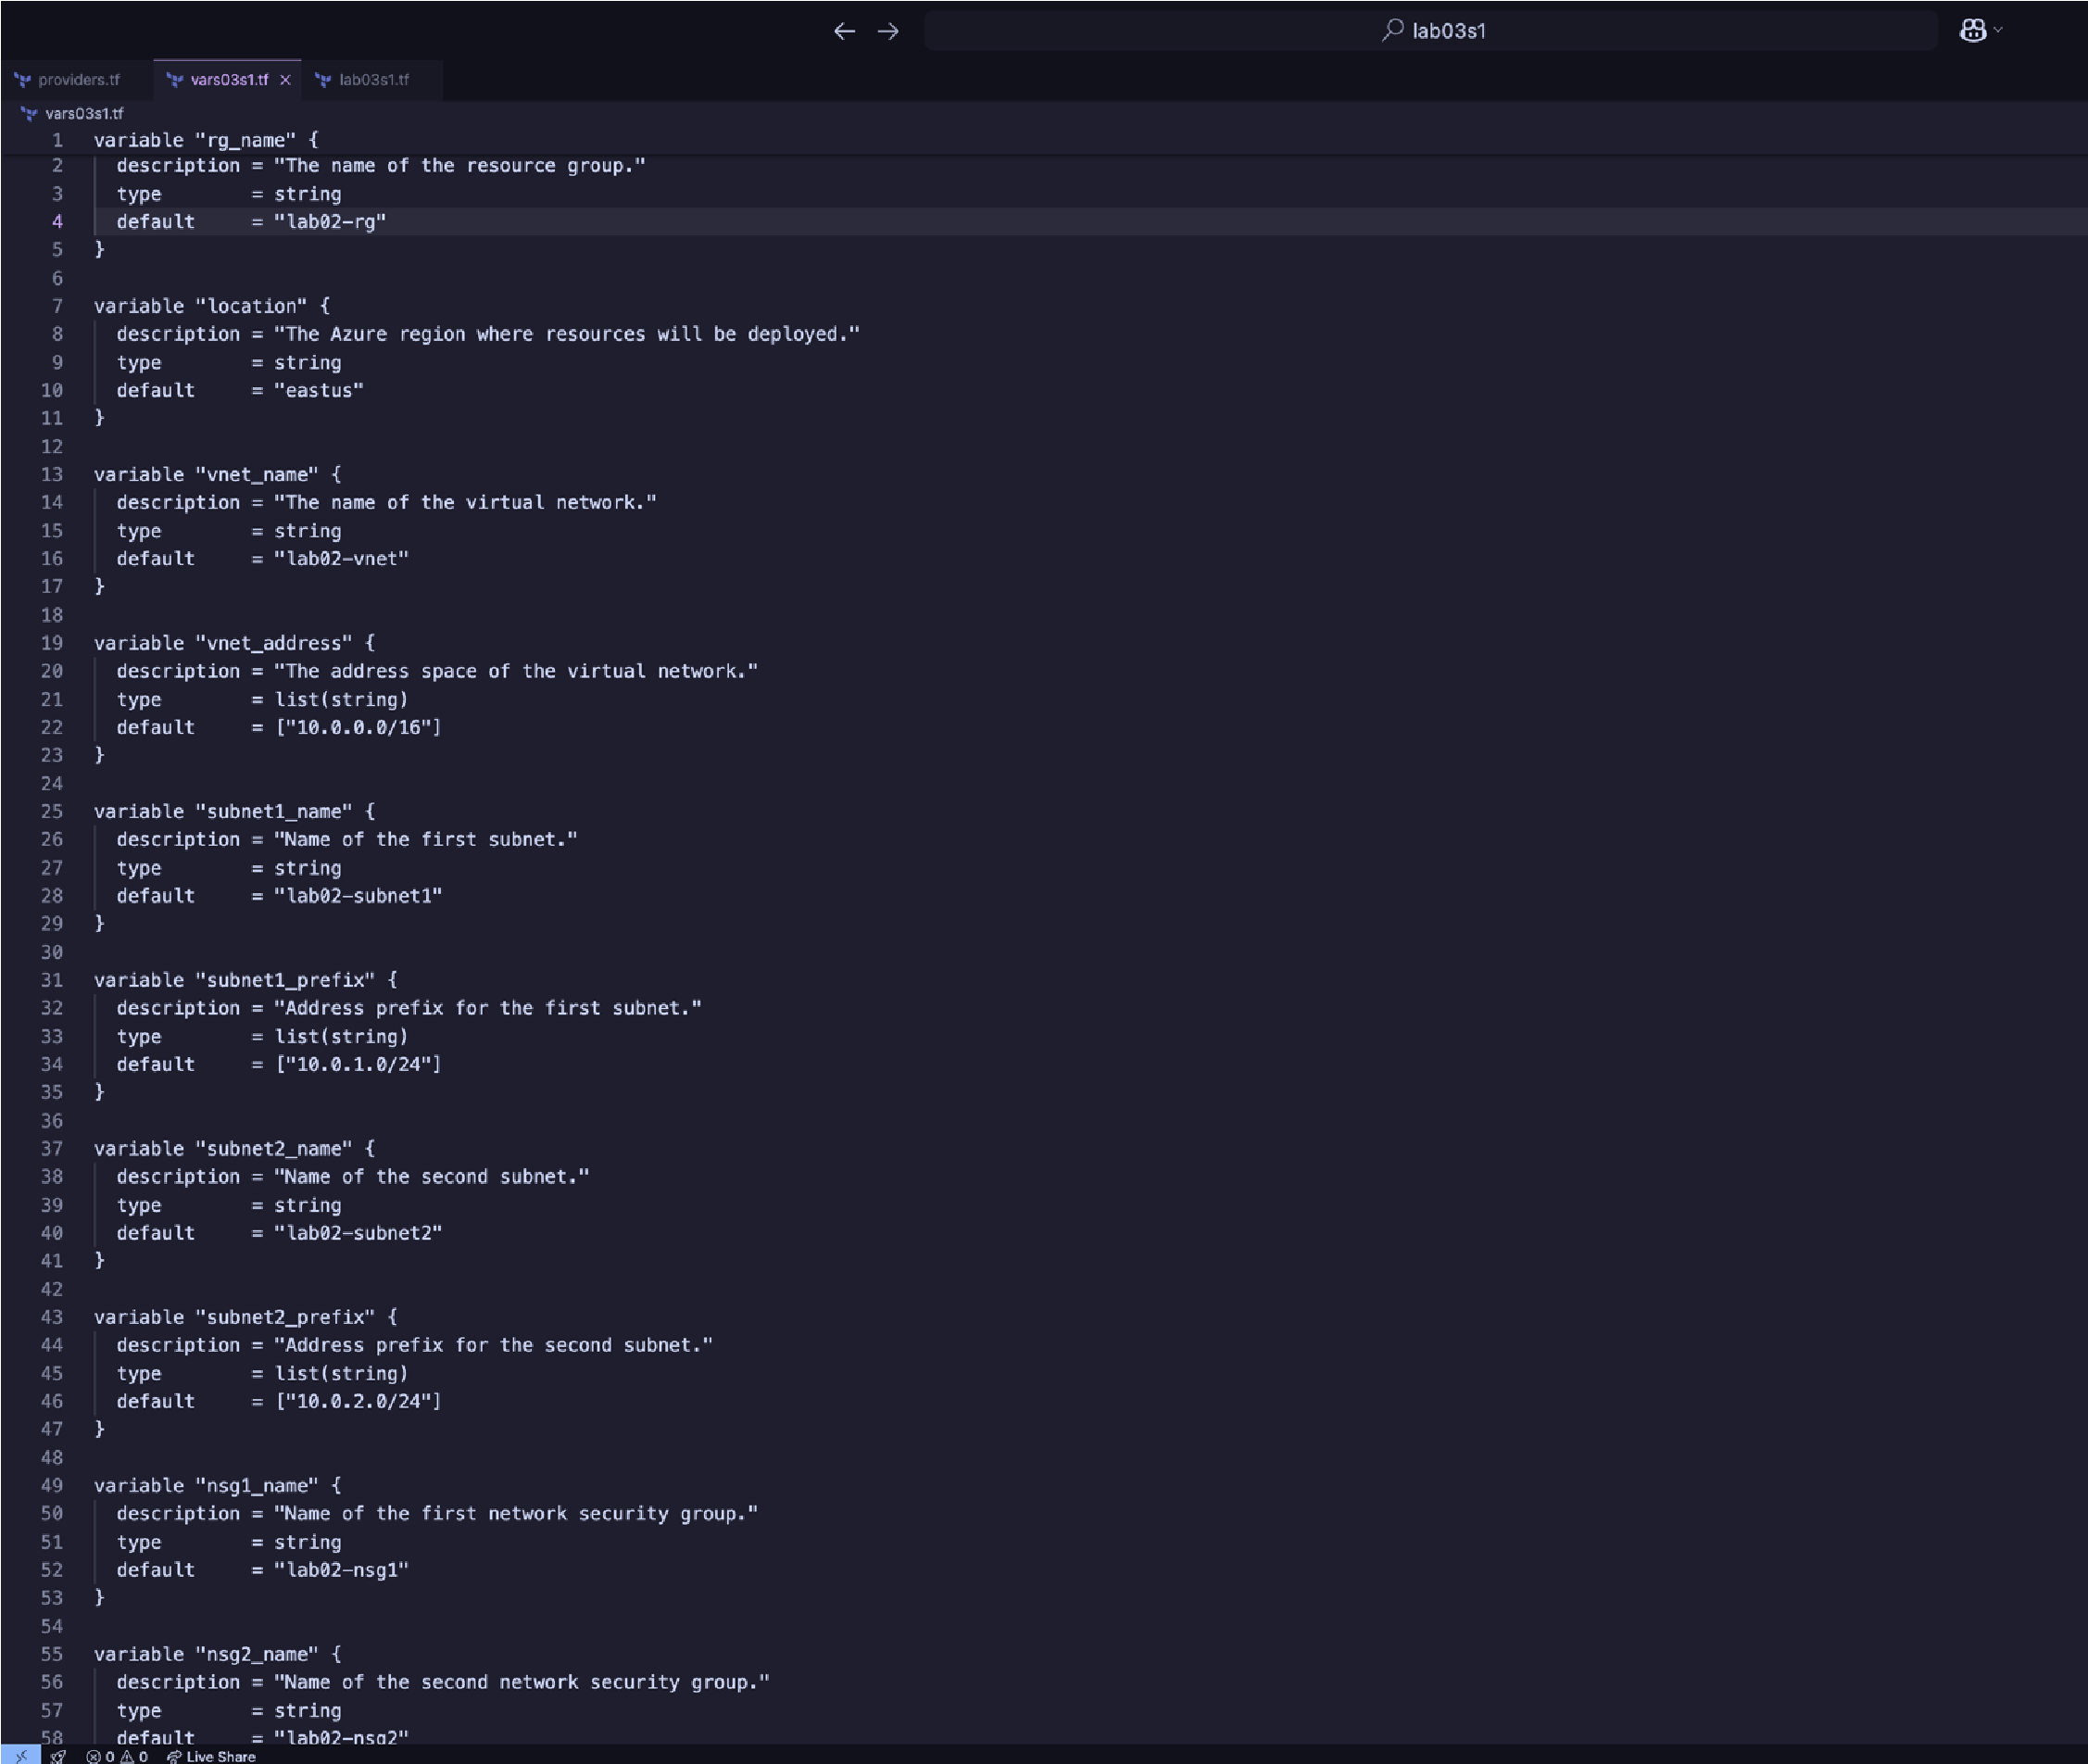Two blocks for network security groups (one per network security group).

## Part 3: Update lab03s1.A File

1. Open lab03s1.‘ in a text editor and update as follows:
   1. Remove provider and Terraform blocks.
   2. Update all resource blocks to source values from vars03s1.‘.

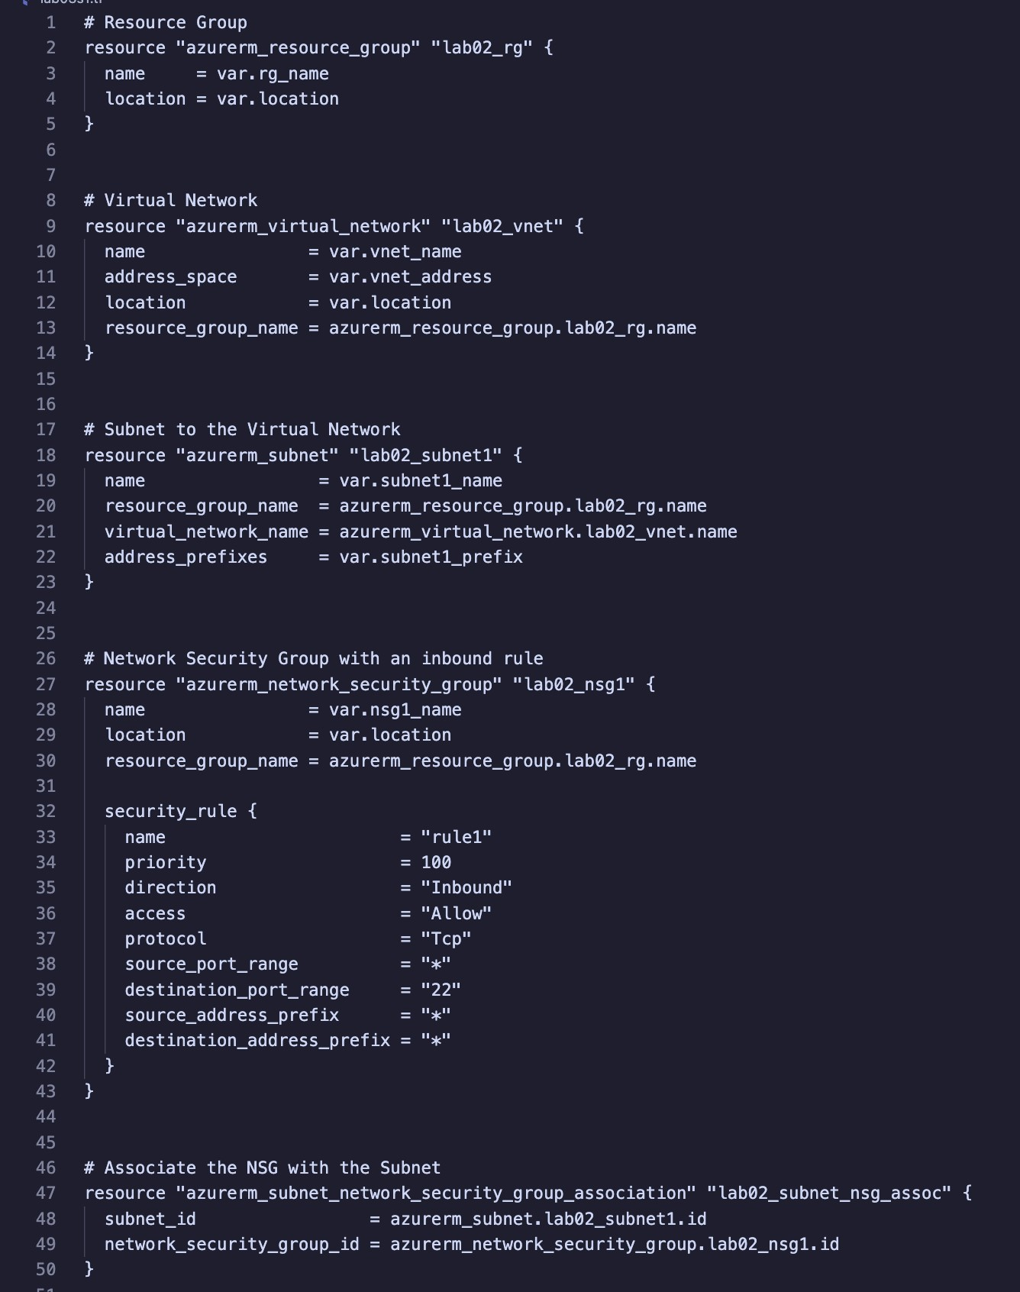

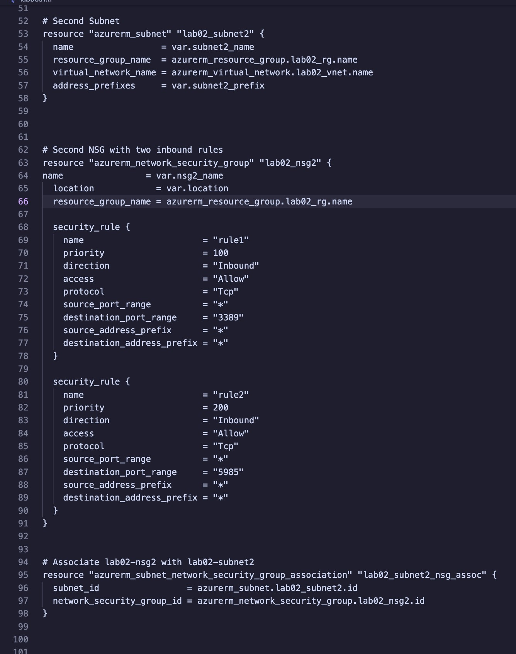

**Part 4: Initialize Terraform**

1. Initialize Terraform to download plug-ins as required:

## Part 5: Validate Configuration

1. Validate the configuration to ensure no errors or typos:
2. Fix any issues in lab03s1.‘ and/or vars03s1.‘ files if reported (edit in your text editor).
3. Re-run validation until no errors are reported.

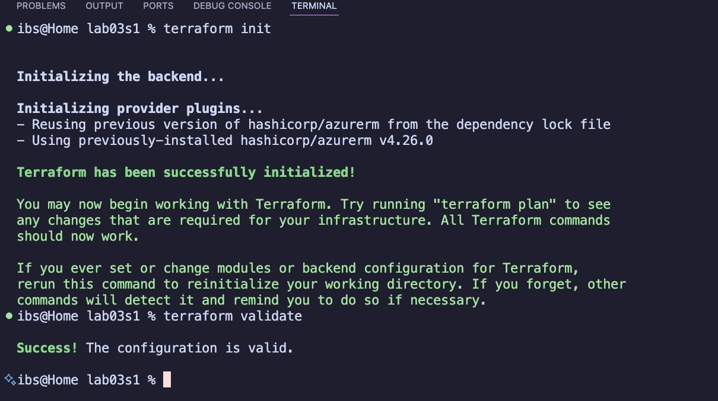

## Part 6: Run Simulation

1. Perform a dry run:

terraform plan

1. Review output and ensure all configuration meets requirements. Observe resources with +, -, or -/+ signs.
2. Fix any issues in lab03s1.‘ and/or vars03s1.‘ files if reported.
3. Redo the dry run until no errors are reported.

## Part 8: Deploy Infrastructure

20. Deploy the infrastructure and monitor progress. o Type yes when prompted.

## Part 9: Get Information from Terraform State

22. View and analyze state information:

terraform state list terraform

show

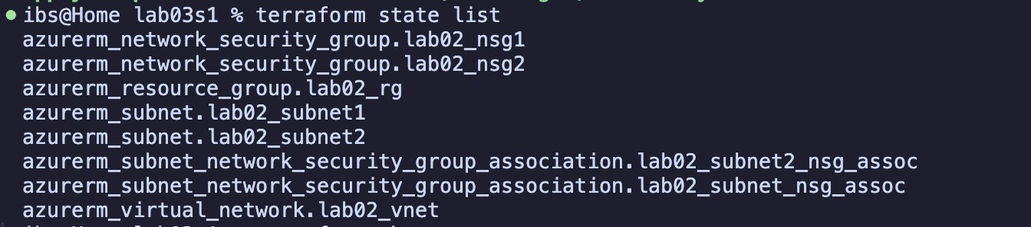

## Part 10: Confirm Resource Creation in Azure

23. Log in to the Azure Portal. Navigate to the resource group and confirm all resources exist as per specifications.

## Part 11: Destroy All Resources and Verify

1. Destroy all resources:

terraform destroy

o Type yes when prompted.

1. Verify deletion:

terraform state list terraform

show

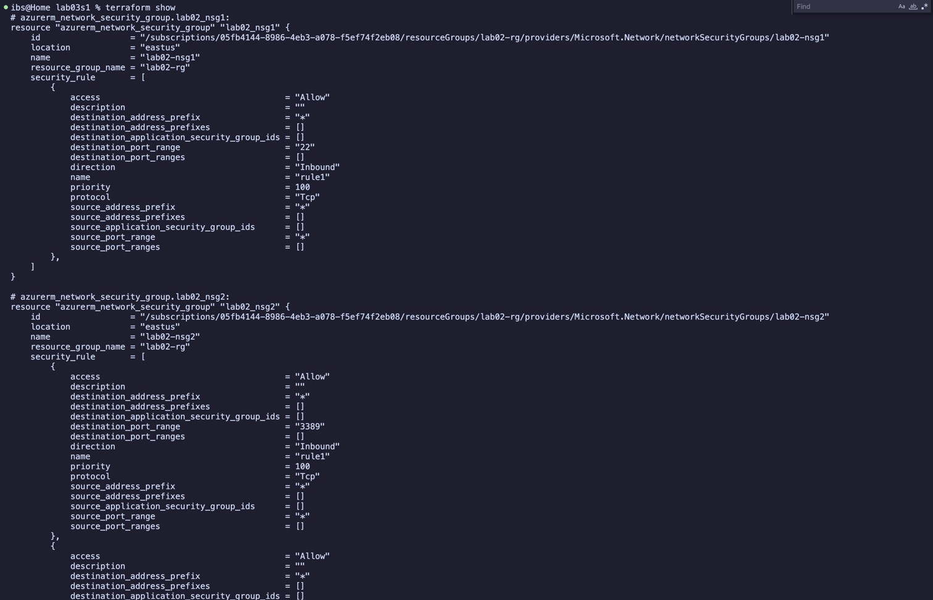

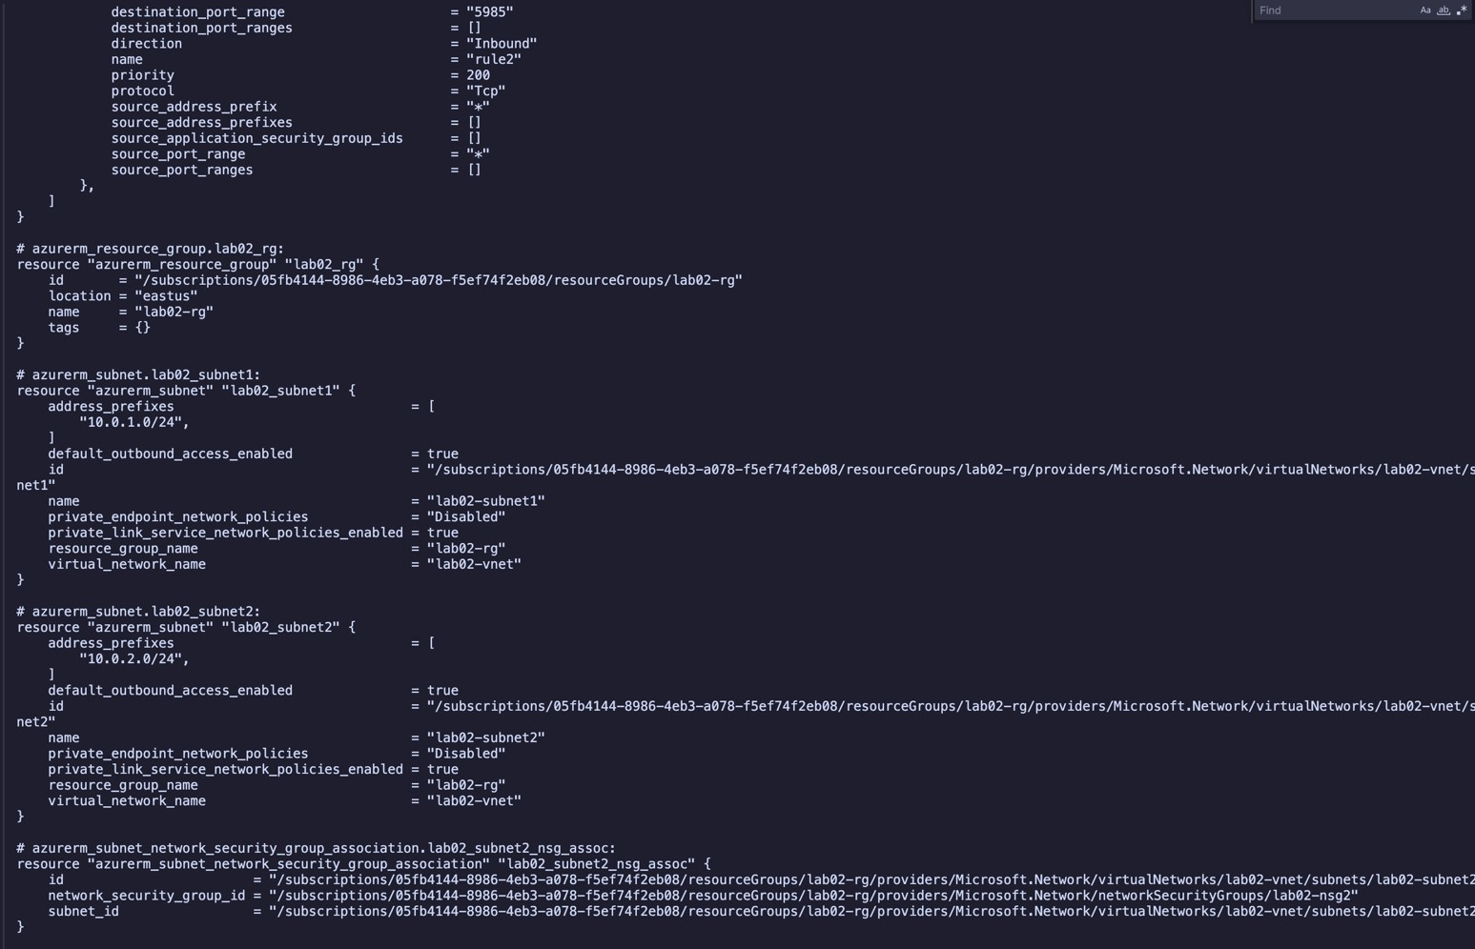

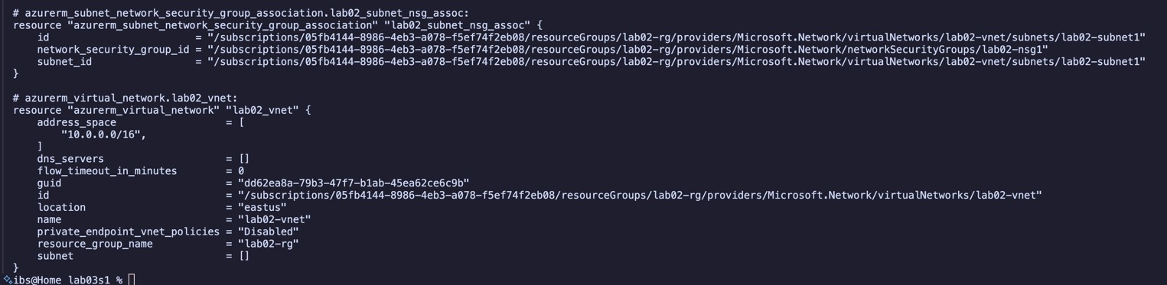

# Section 2

**Objectives:**  • Use configuration from Section 1.

• Define resource and variable blocks for virtual machine resources. Validate, deploy, expand, analyze, and destroy infrastructure.

## Part 1: Prepare for the Lab

1. Create a directory called lab03s2 in your home directory:
2. Copy lab03s1.‘, vars03s1.‘, and providers.‘ into lab03s2 directory:
3. Change into the lab03s2 directory:
4. Create two empty files called lab03s2.‘ and vars03s2.‘:

## Part 2: Update vars03s2.A File

5. Open vars03s2.‘ in a text editor and define variable blocks for a Linux virtual machine. Enclose values in double quotation marks:

1. Name (e.g., linux_name): "lab03s2-db1-u-vm1".
2. Size: "Standard_B1s".
3. Admin user name: "<firstname-yourHumberID>" [from Lab 01].
4. Public key: "C:\Users\<YourWindowsUsername>\.ssh\id_rsa.pub" (adjust path to your SSH public key location on Windows). e. OS disk aoributes:

i. Storage account type: "Premium_LRS". ii.

Disk size: "32".

iii. Caching: "ReadWrite".

f. Ubuntu Linux OS information:

i. Publisher: "Canonical". ii. Offer: "UbuntuServer". iii. Sku: "19.04". iv.

Version: "latest".

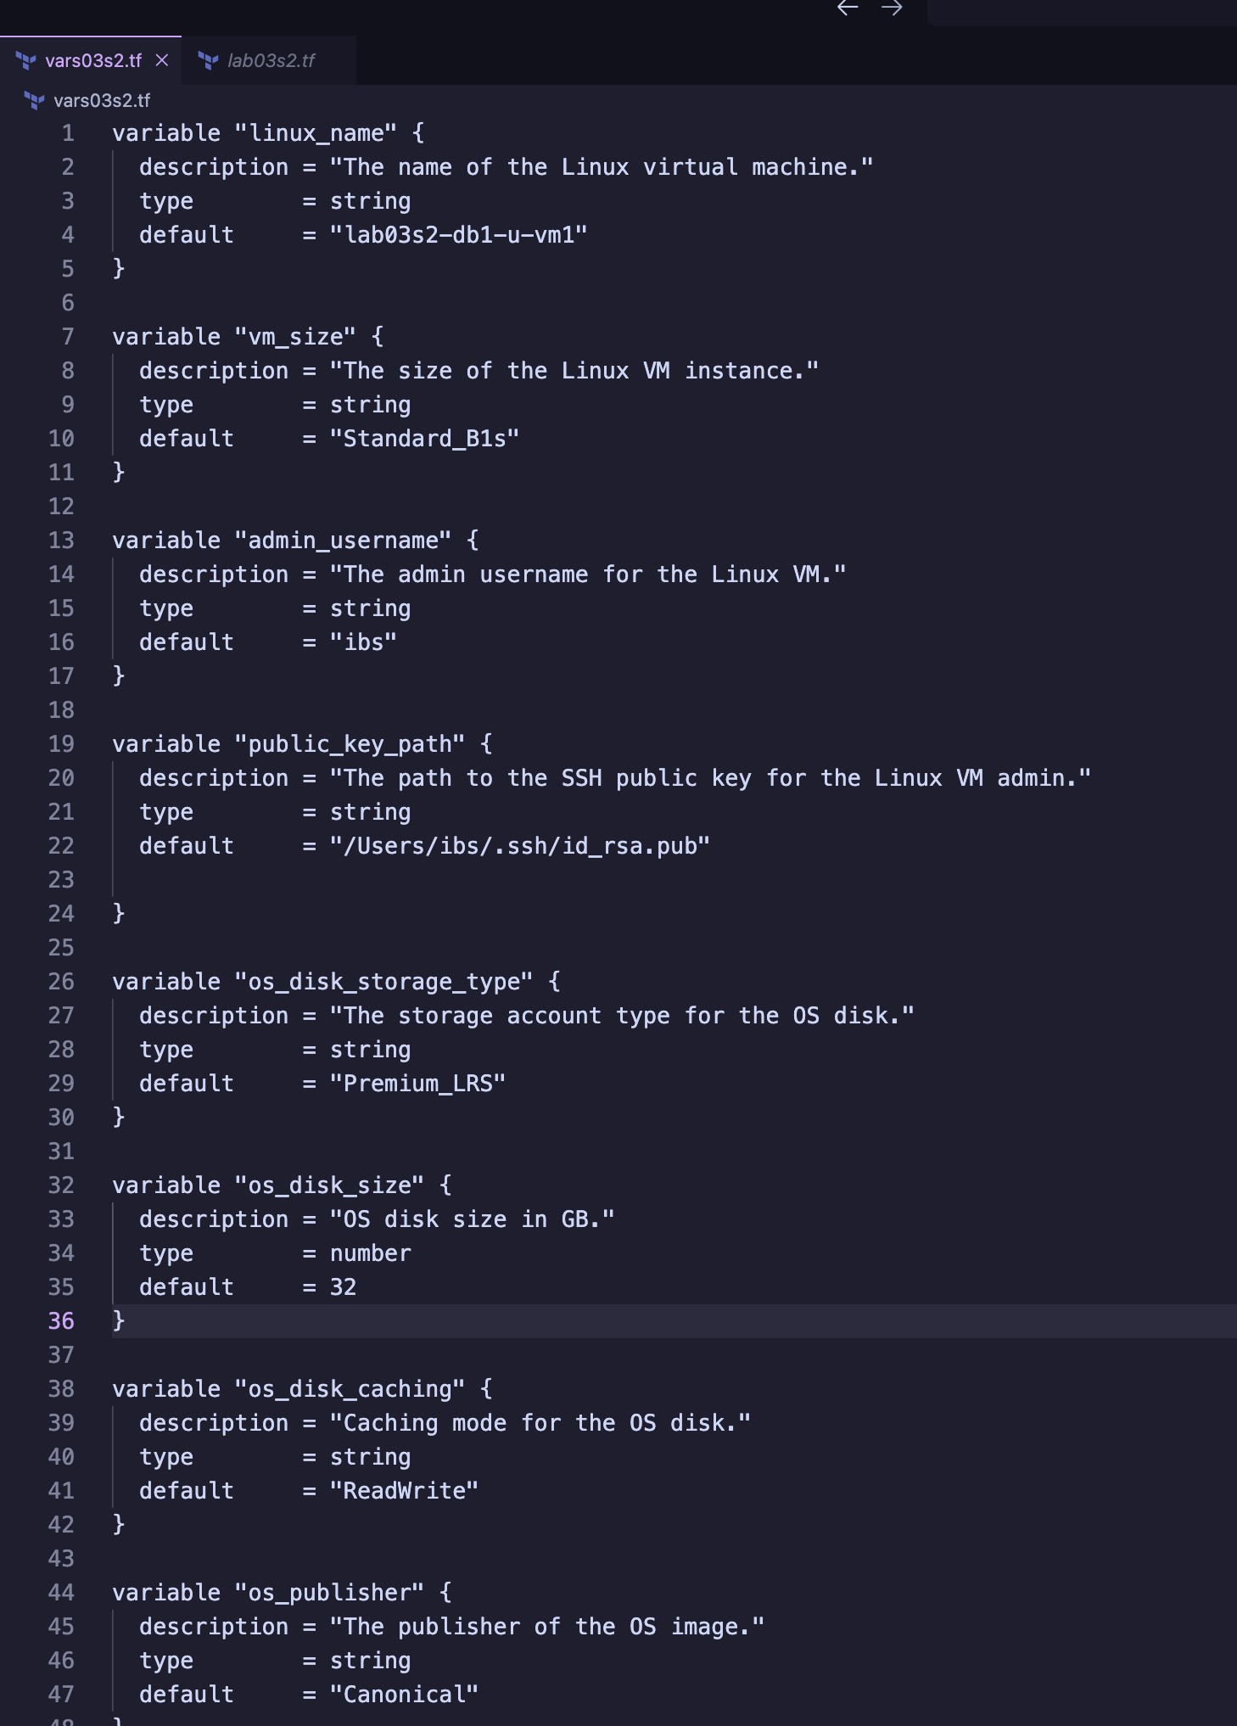

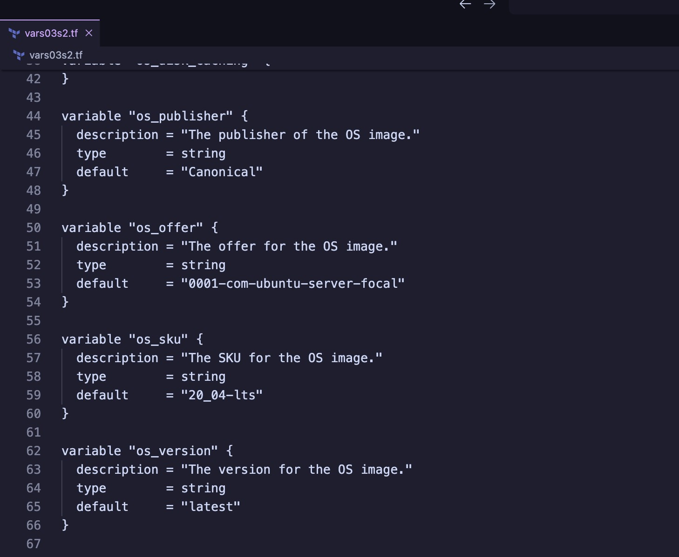

## Part 3: Update lab03s2.A File

1. Open lab03s2.‘ in a text editor and define resource blocks as follows:

a. Define network interface called ${var.linux_name}-nic with IP configuration name

${var.linux_name}-ipconfig1 using azurerm_network_interface. Use Dynamic IP address allocation. b. Define public IP address called ${var.linux_name}-pip using azurerm_public_ip. Use Dynamic IP address allocation method.

c. Define virtual machine using azurerm_linux_virtual_machine. Use ${var.linux_name}-osdisk as the OS

disk name.

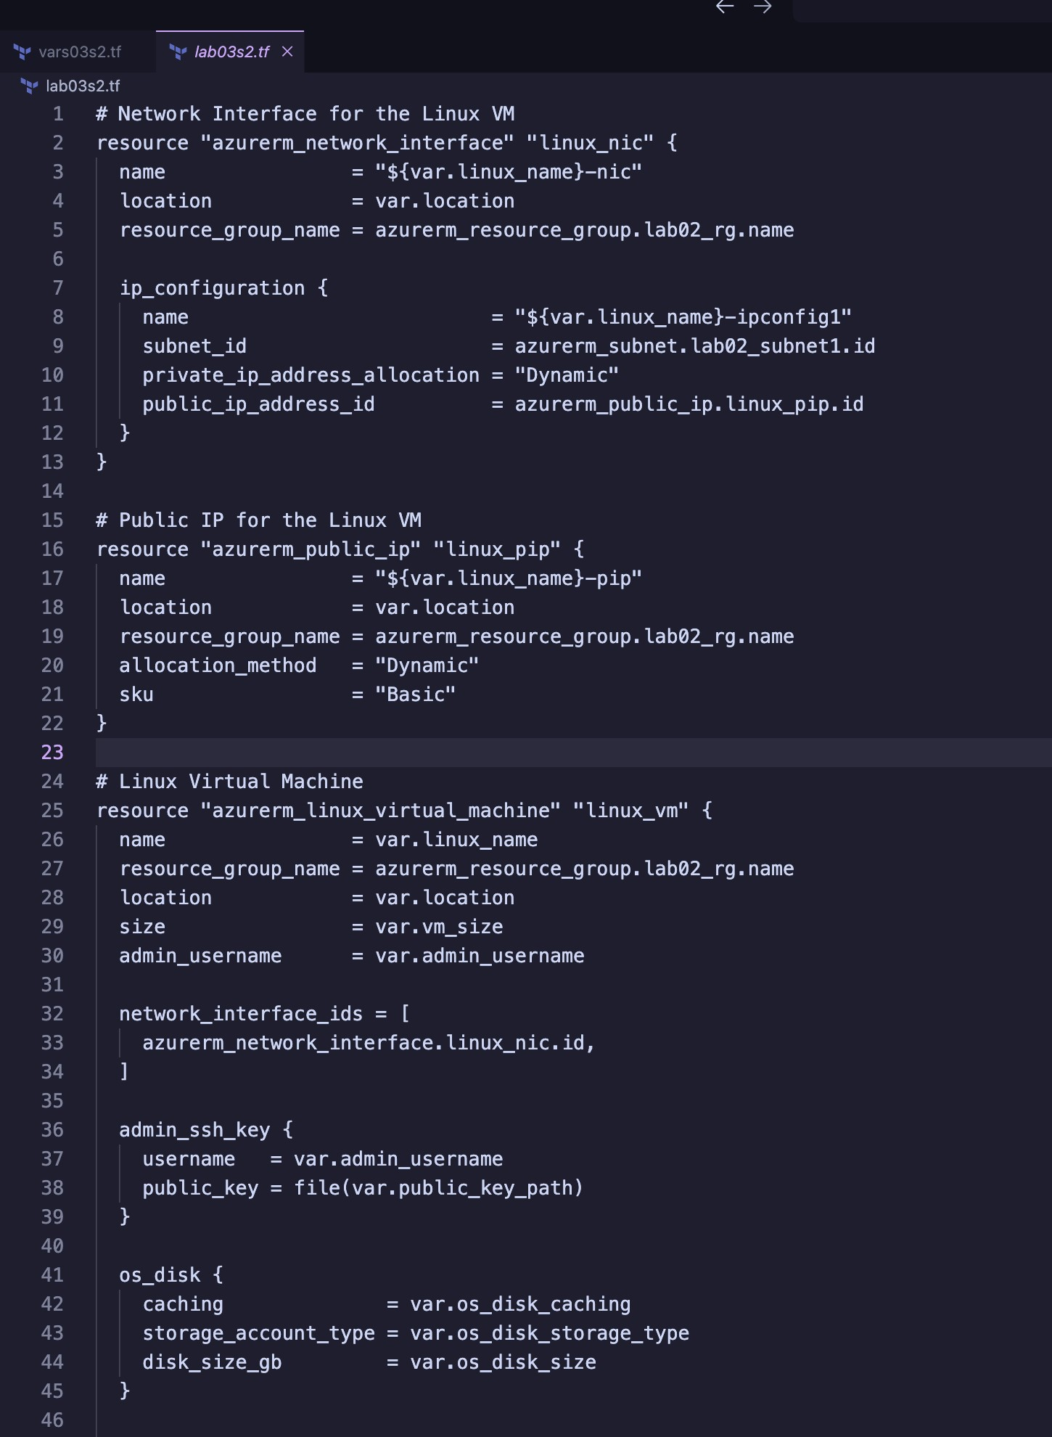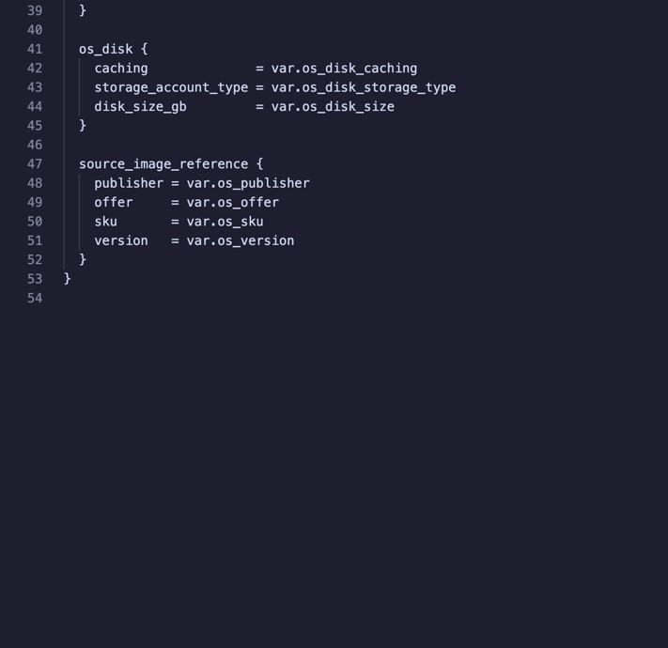

|  |  |
| --- | --- |
| *Note: At this point, you should have 5 Terraform files—providers.<, lab03s1.<, vars03s1.<, lab03s2.<, and* | |
| *vars03s2.<—under the lab03s2 directory.* |  |

**Part 4: Initialize Terraform**

1. Initialize Terraform to download plug-ins as required:

## Part 5: Validate Configuration

8. Validate the configuration to ensure no errors or typos:

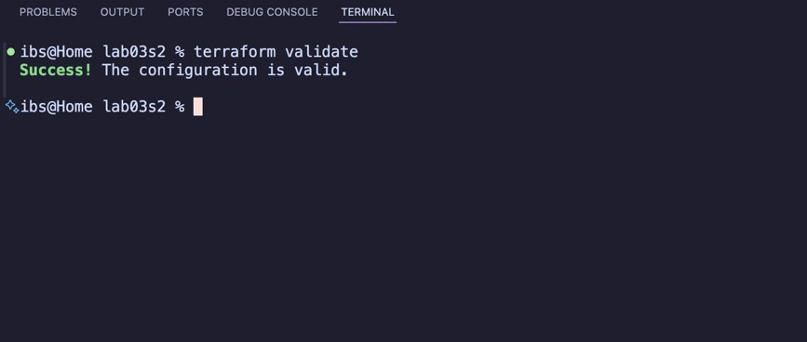

## Part 6: Run Simulation

1. Perform a dry run:

terraform plan

1. Review output and ensure all configuration meets requirements. Observe resources with +, -, or -/+ signs.
2. Fix any issues in the Terraform files if reported.
3. Redo the dry run until no errors are reported:

**Part 7: Deploy Infrastructure**

1. Deploy the infrastructure and monitor progress:

## Part 8: Get Information from Terraform State

17. View and analyze state information:

terraform state list terraform

show

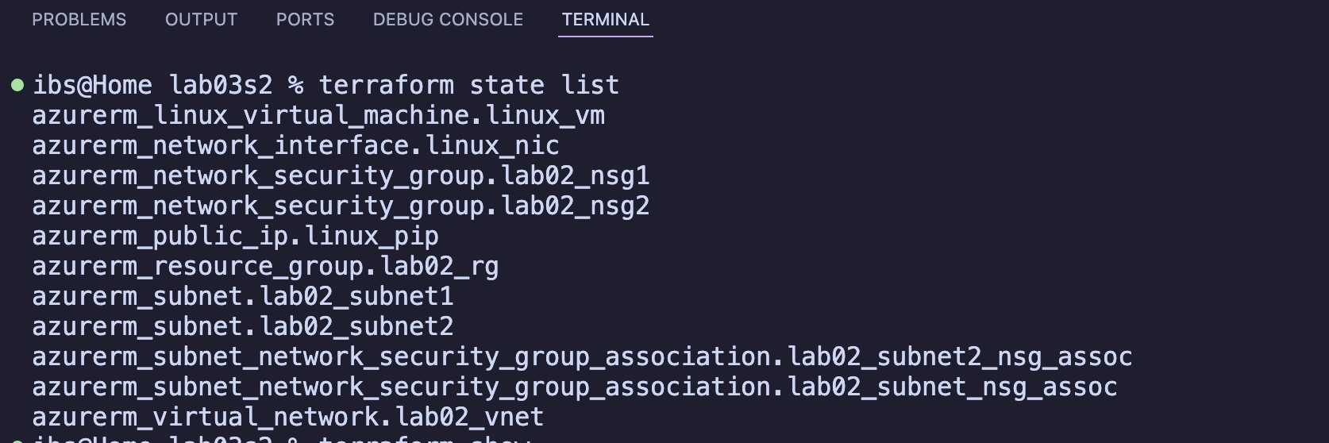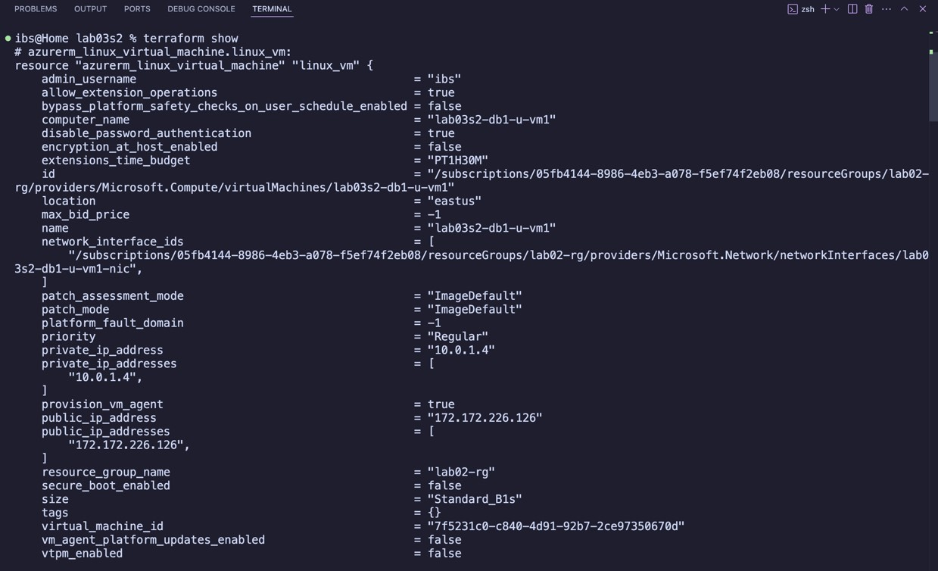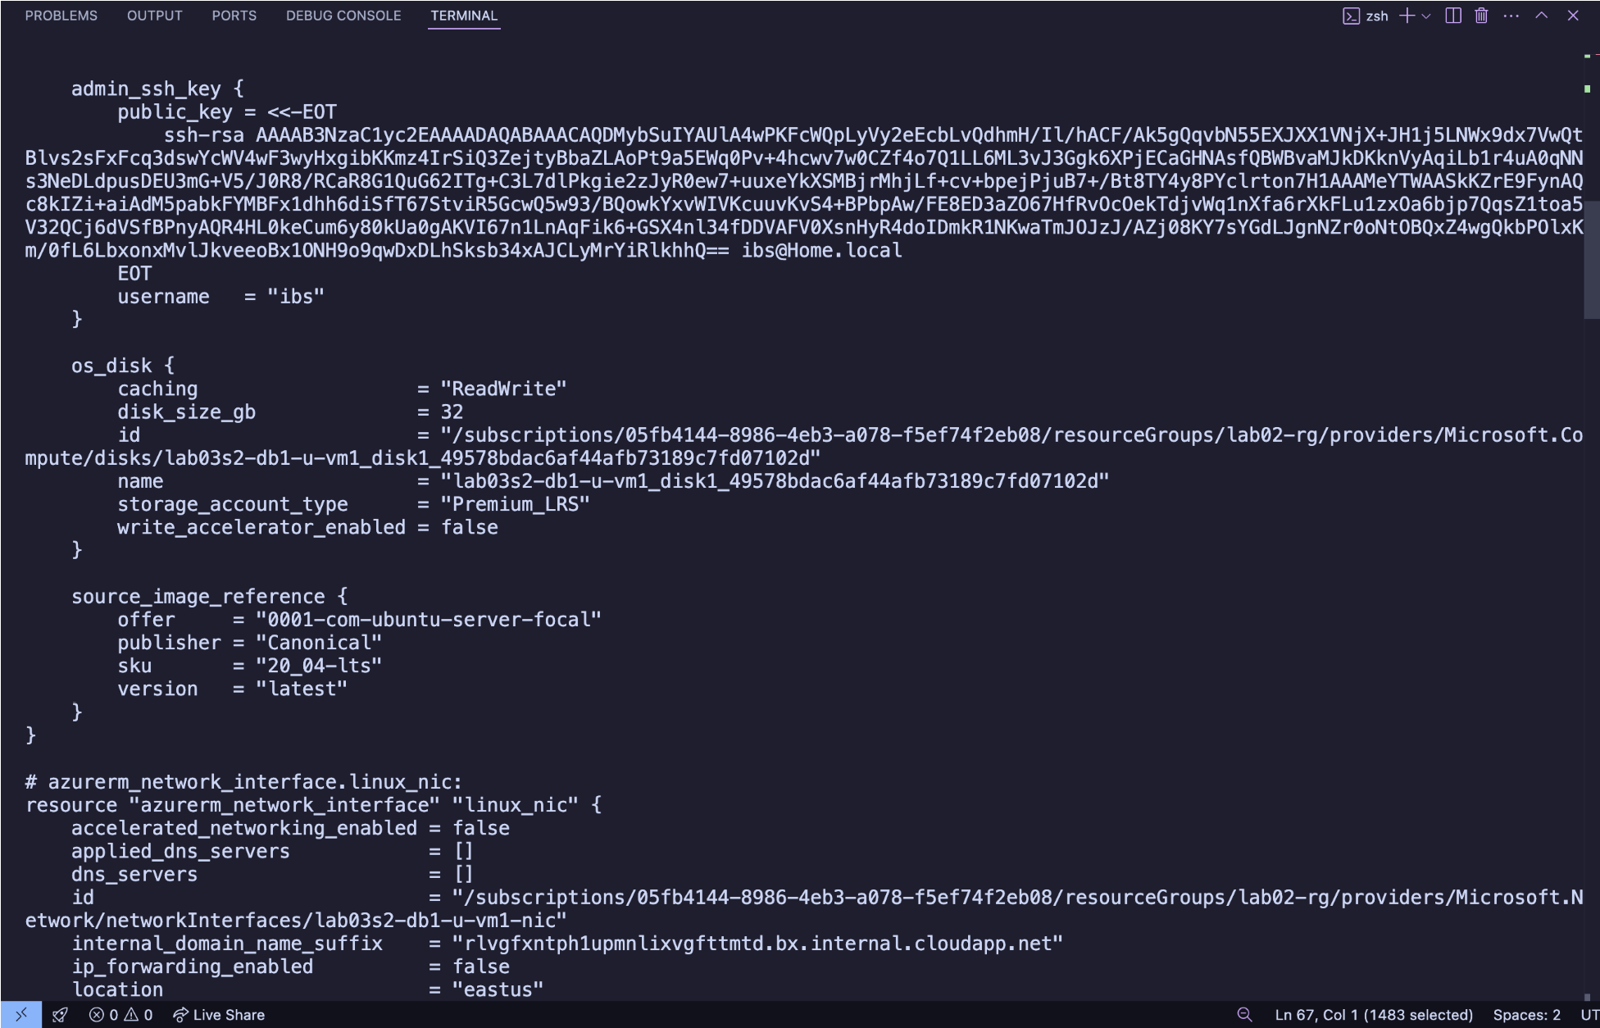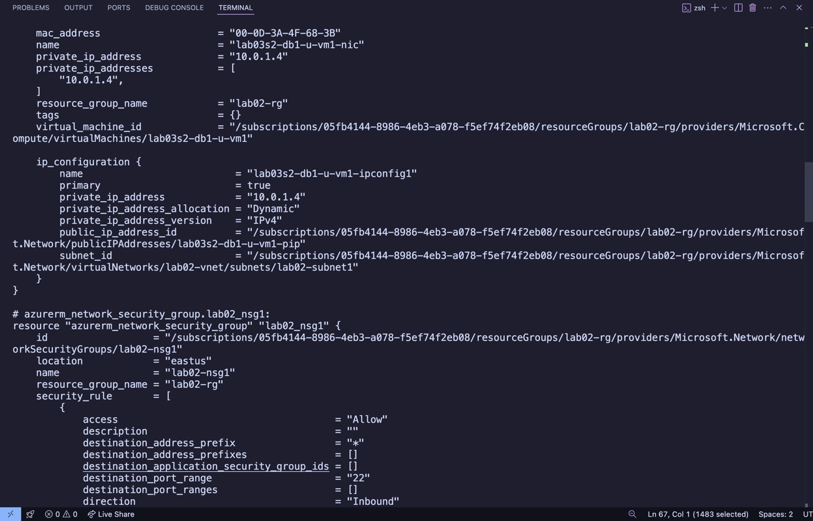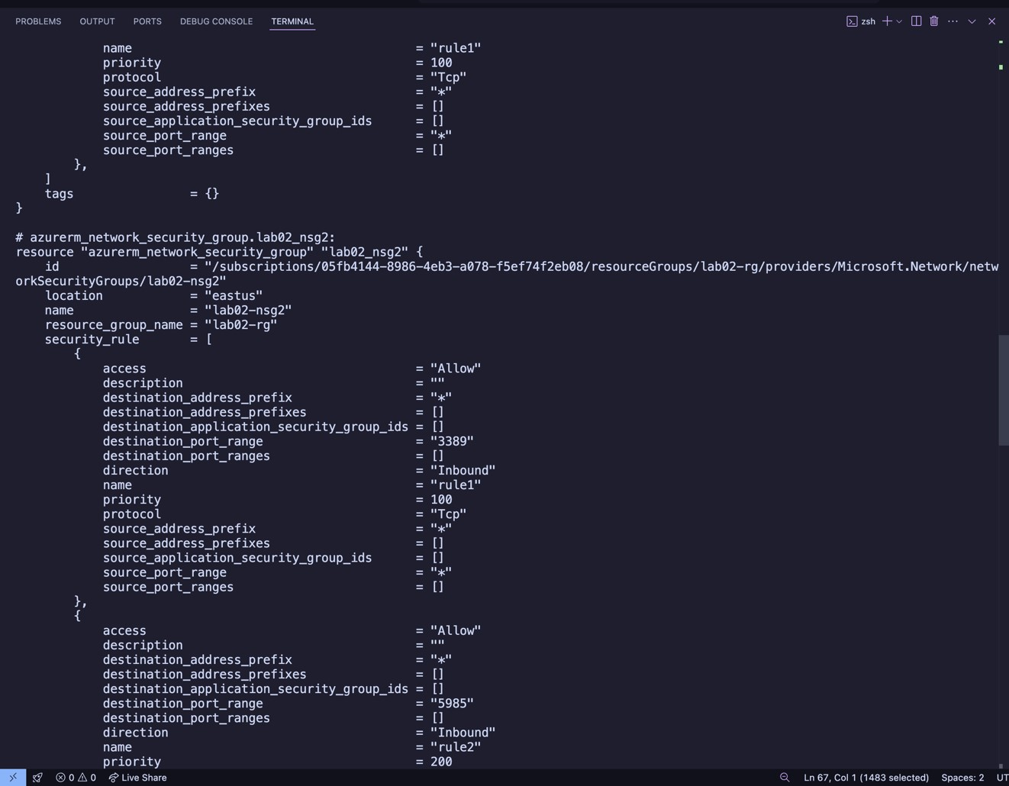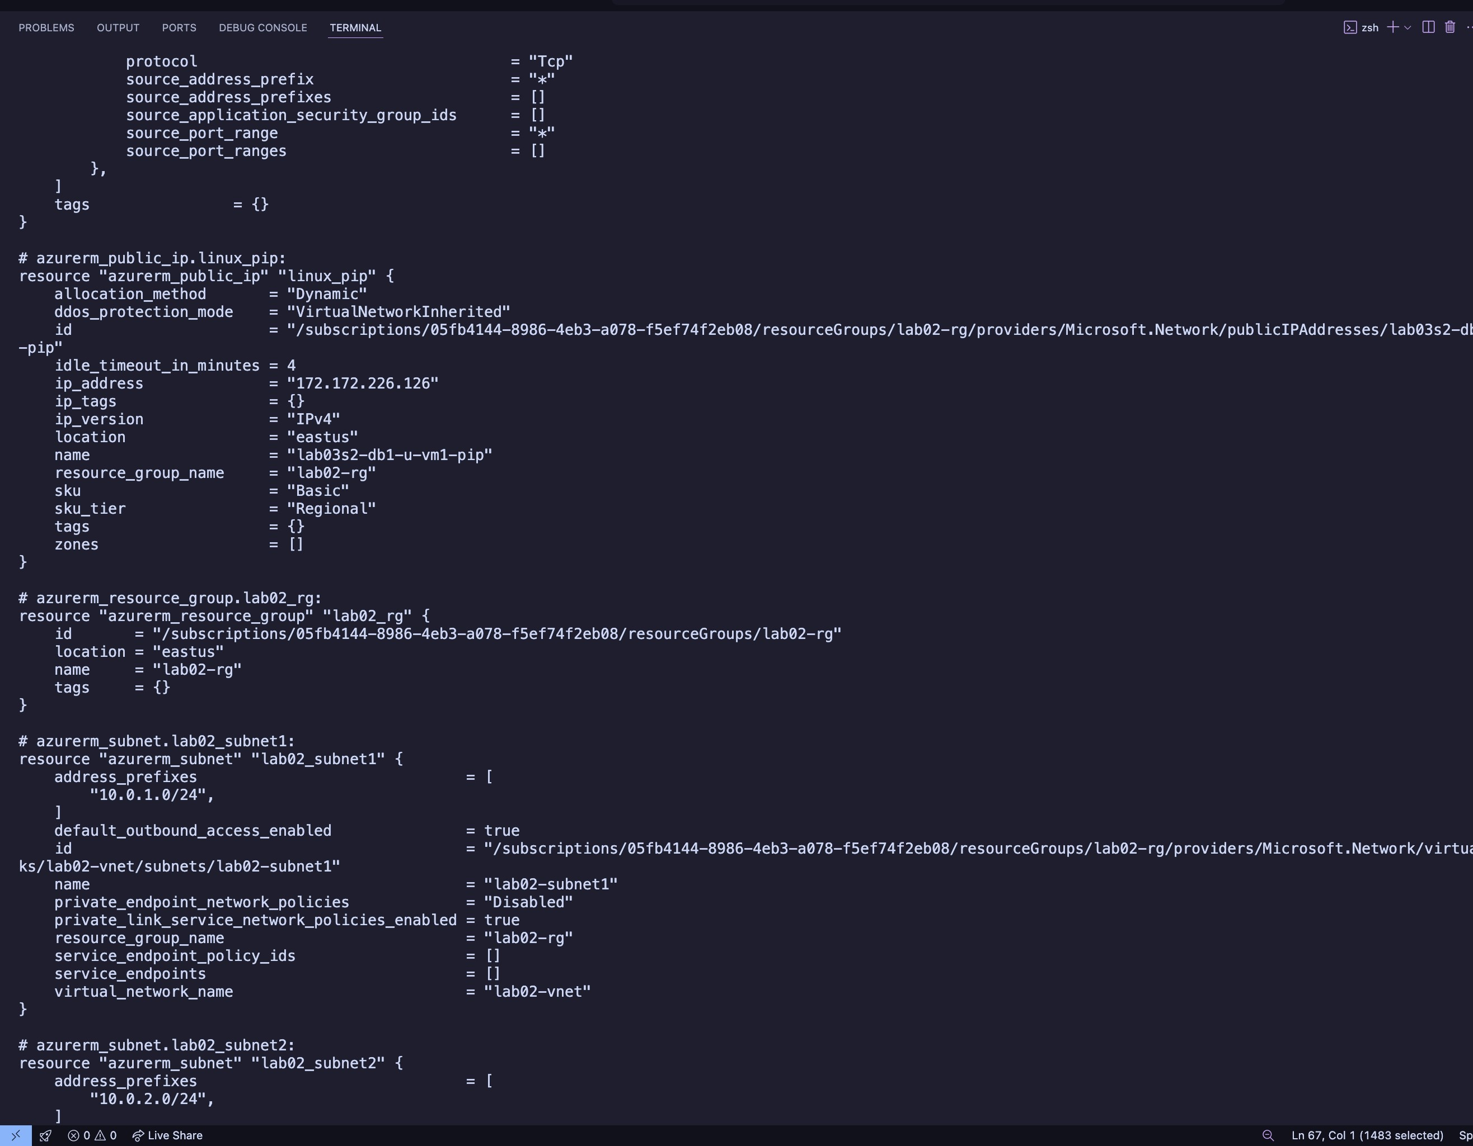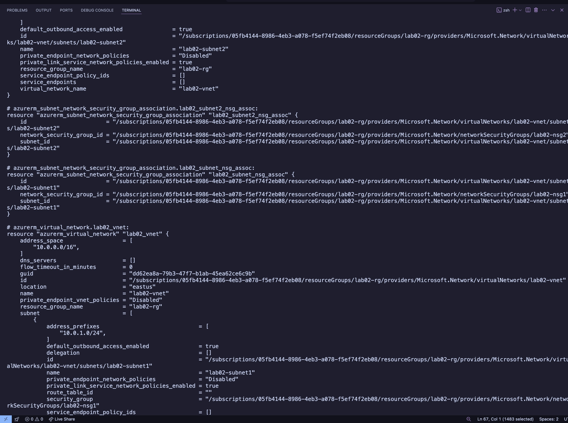

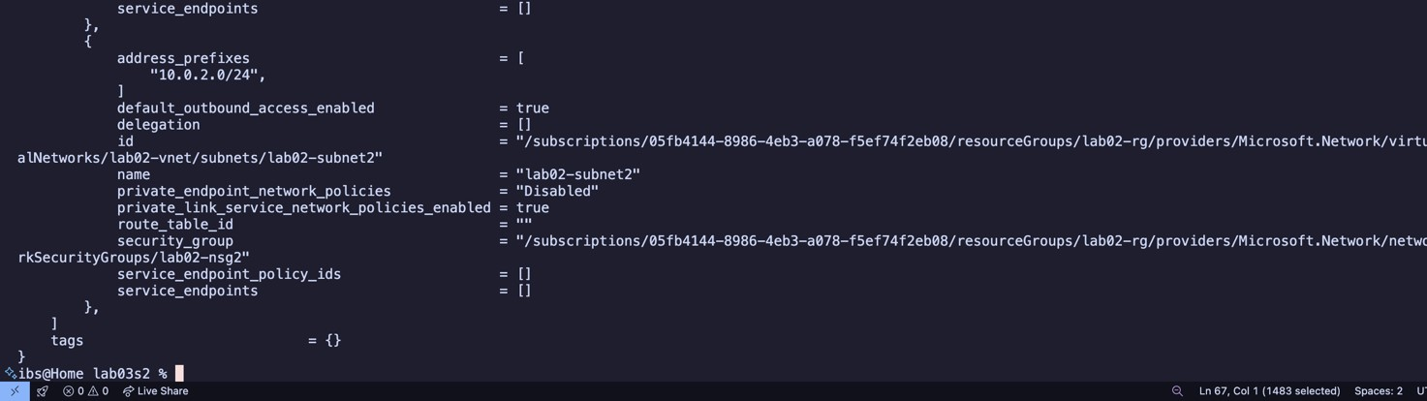

## Part 9: Confirm Resource Creation in Azure

18. Log in to the Azure Portal. Navigate to the resource group and confirm all resources exist as per specifications.

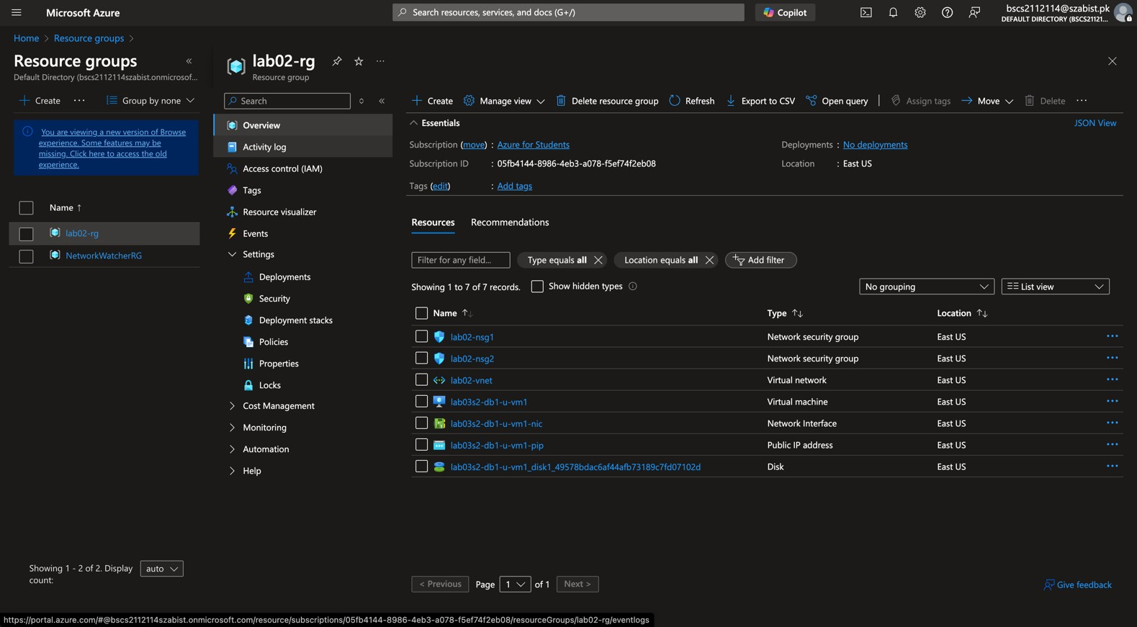

## Part 10: Destroy All Resources and Verify

1. Destroy all resources:

terraform destroy

o Type yes when prompted.

1. Verify deletion:

terraform state list terraform

show

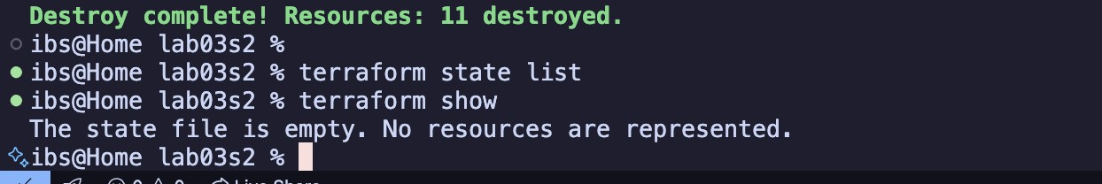

# Section 3

**Objectives:**

* Use configuration from Section 2.
* Define a locals block to assign tags to resources.
* Validate, deploy, expand, analyze, and destroy infrastructure.

## Part 1: Prepare for the Lab

1. Create a directory called lab03s3 in your home directory:
2. Copy lab03s1.‘, vars03s1.‘, lab03s2.‘, vars03s2.‘, and providers.‘ into lab03s3 directory:
3. Change into the lab03s3 directory:
4. Rename lab03s2.‘ as lab03s3.‘ and vars03s2.‘ as vars03s3.‘:

## Part 2: Update vars03s3.A File

5. Open vars03s3.‘ in a text editor and define a locals block at the beginning with the following values.

Enclose values in double quotation marks: a. Name: "Terraform-Class".

1. Project: "Learning".
2. ContactEmail: "youremailaddress".
3. Environment: "Lab".

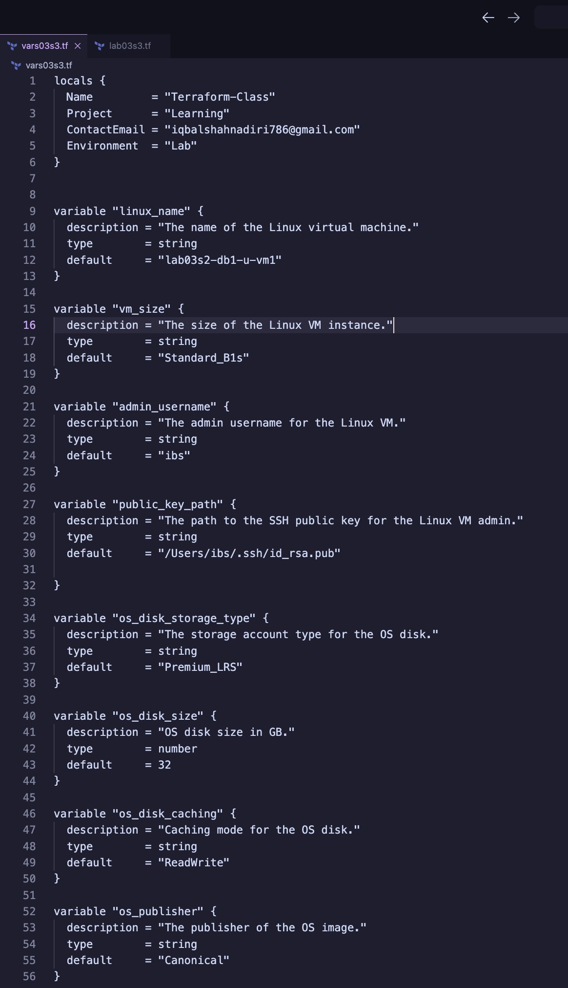

## Part 3: Update lab03s3.A File

1. Open lab03s3.‘ in a text editor and add tags to network interface, public IP, and virtual machine resource blocks using the locals values.

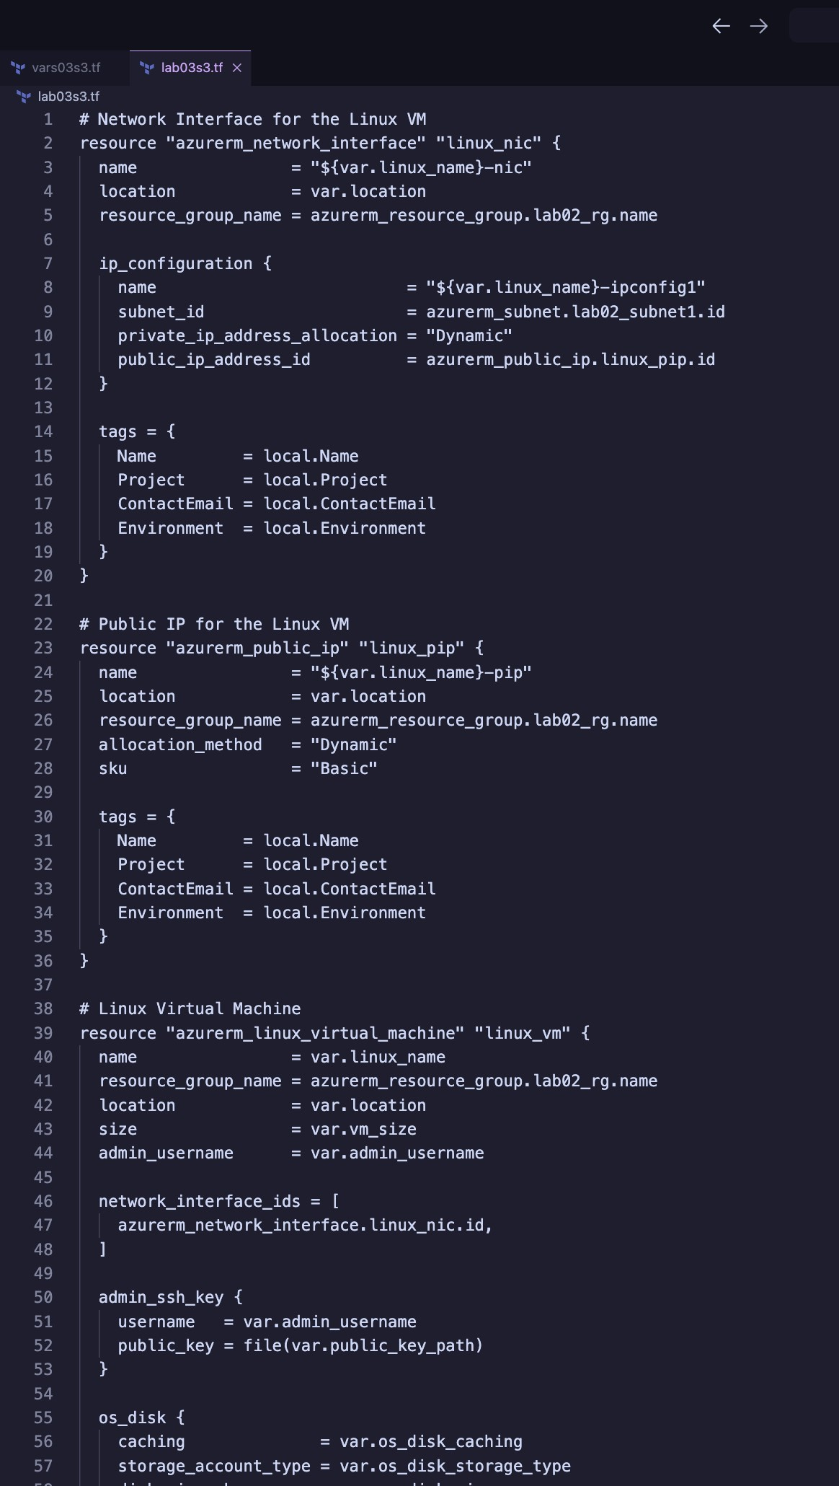

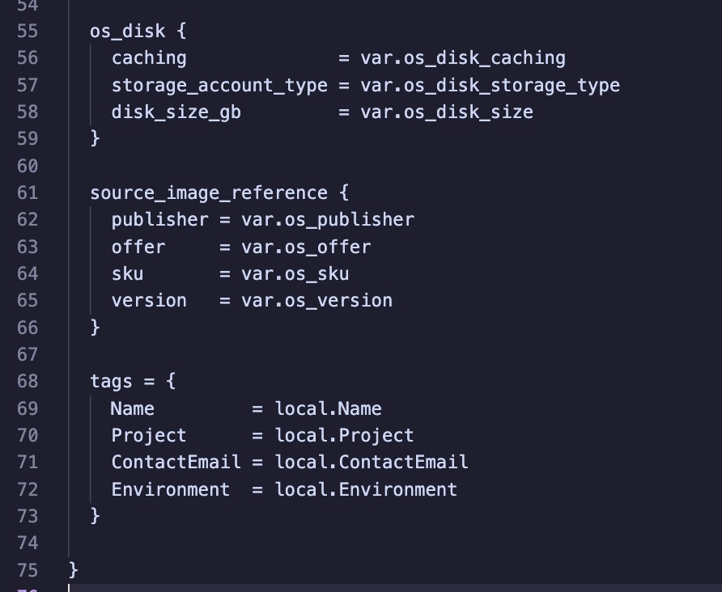

**Part 4: Initialize Terraform**

1. Initialize Terraform to download plug-ins as required:

## Part 5: Validate Configuration

1. Validate the configuration to ensure no errors or typos:
2. Fix any issues in the Terraform files if reported.
3. Re-run validation until no errors are reported:

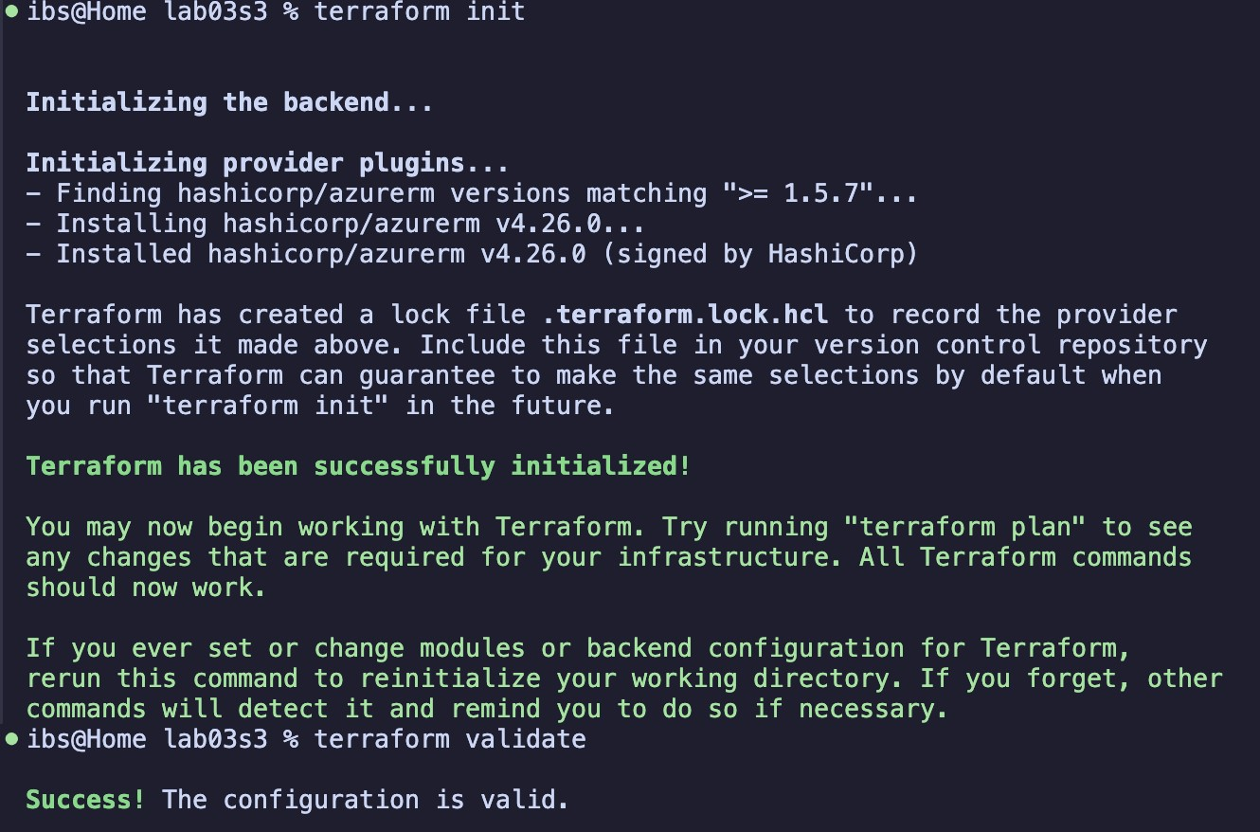

## Part 6: Run Simulation

1. Perform a dry run:

terraform plan

1. Review output and ensure all configuration meets requirements. Observe resources with +, -, or -/+ signs.
2. Fix any issues in the Terraform files if reported.
3. Redo the dry run until no errors are reported:

## Part 7: Deploy Infrastructure

15. Deploy the infrastructure and monitor progress:

terraform apply

o Type yes when prompted.

## Part 8: Get Information from Terraform State

17. View and analyze state information:

terraform state list terraform

show

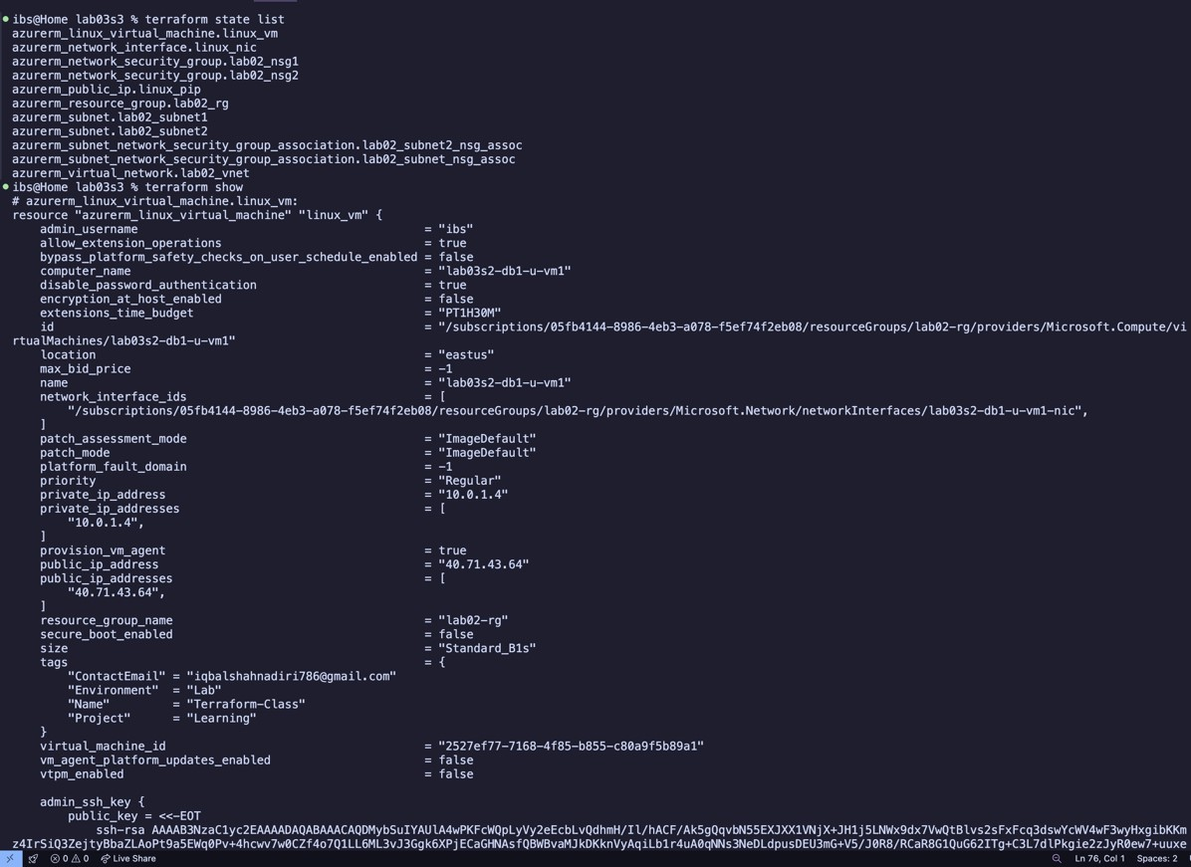

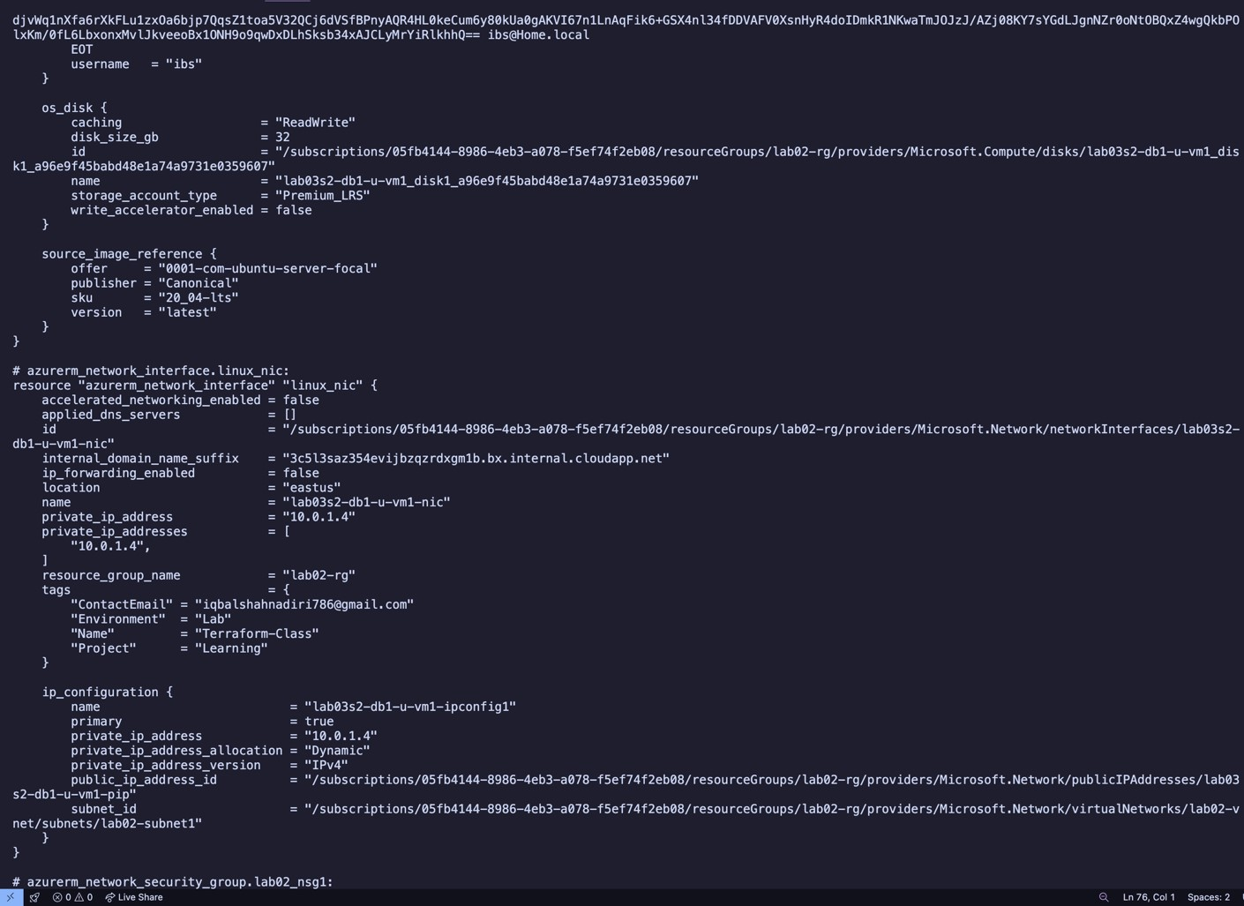

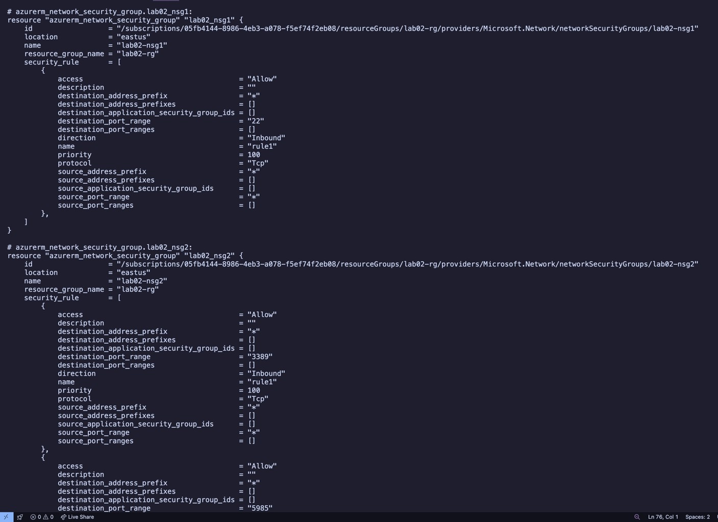

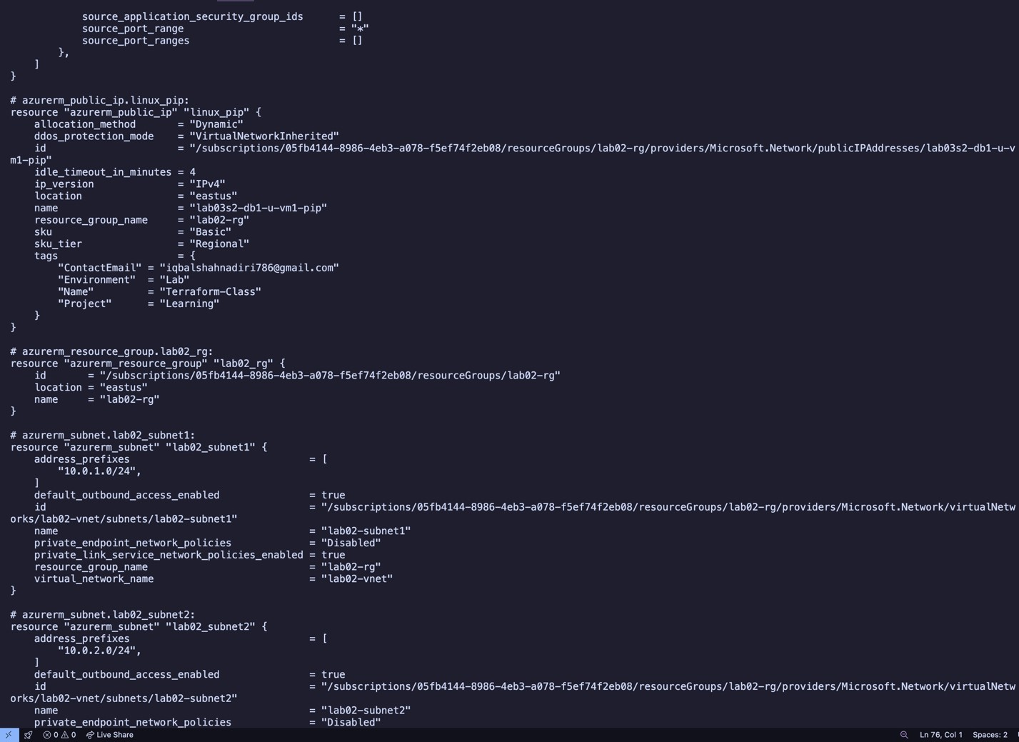

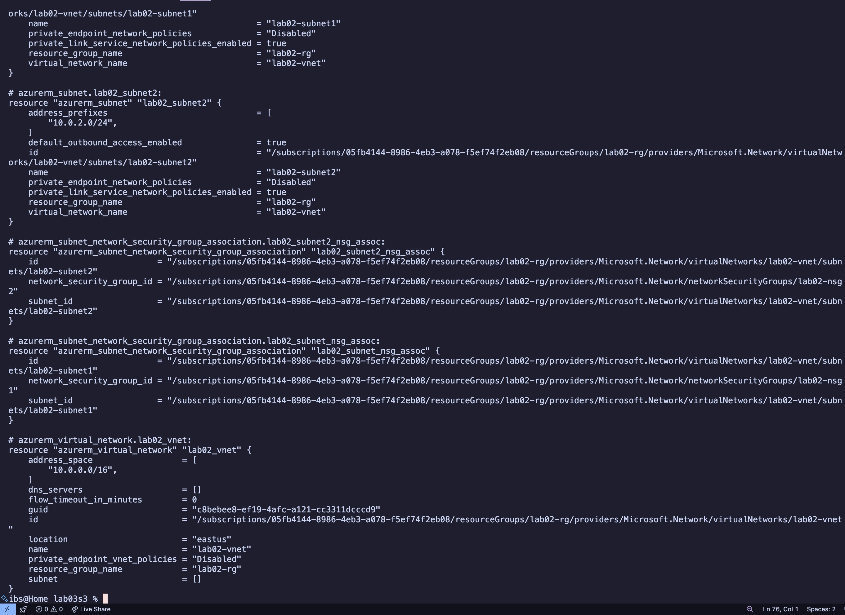

## Part 9: Confirm Resource Creation in Azure

18. Log in to the Azure Portal. Navigate to the resource group and confirm all resources and tags exist as per specifications.

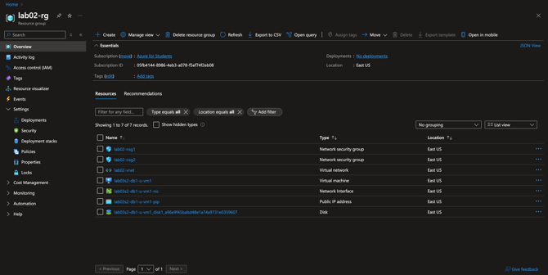

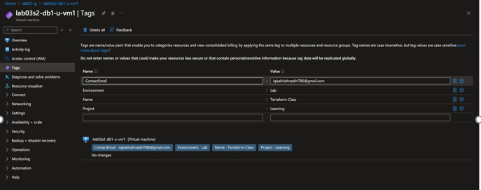

## Part 10: Destroy All Resources and Verify

1. Destroy all resources:

terraform destroy

o Type yes when prompted.

1. Verify deletion:

terraform state list terraform

show

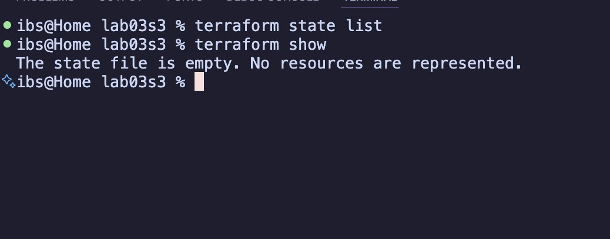

# Section 4

**Objectives:**

* Use configuration from Section 3.
* Define output blocks to display values.
* Validate, deploy, expand, analyze, and destroy infrastructure.

## Part 1: Prepare for the Lab

1. Copy the lab03s3 directory as lab03s4:
2. Change into the lab03s4 directory:
3. Create an empty file called outputs03s4.‘:

## Part 2: Update outputs03s4.A File

4. Open outputs03s4.‘ in a text editor and define output blocks to display:

1. VM hostname (1 block).
2. Private IP address (1 block) and Public IP address (1 block).
3. Virtual network name (1 block) and address space (1 block).
4. Subnet names (2 blocks) and address spaces (2 blocks).

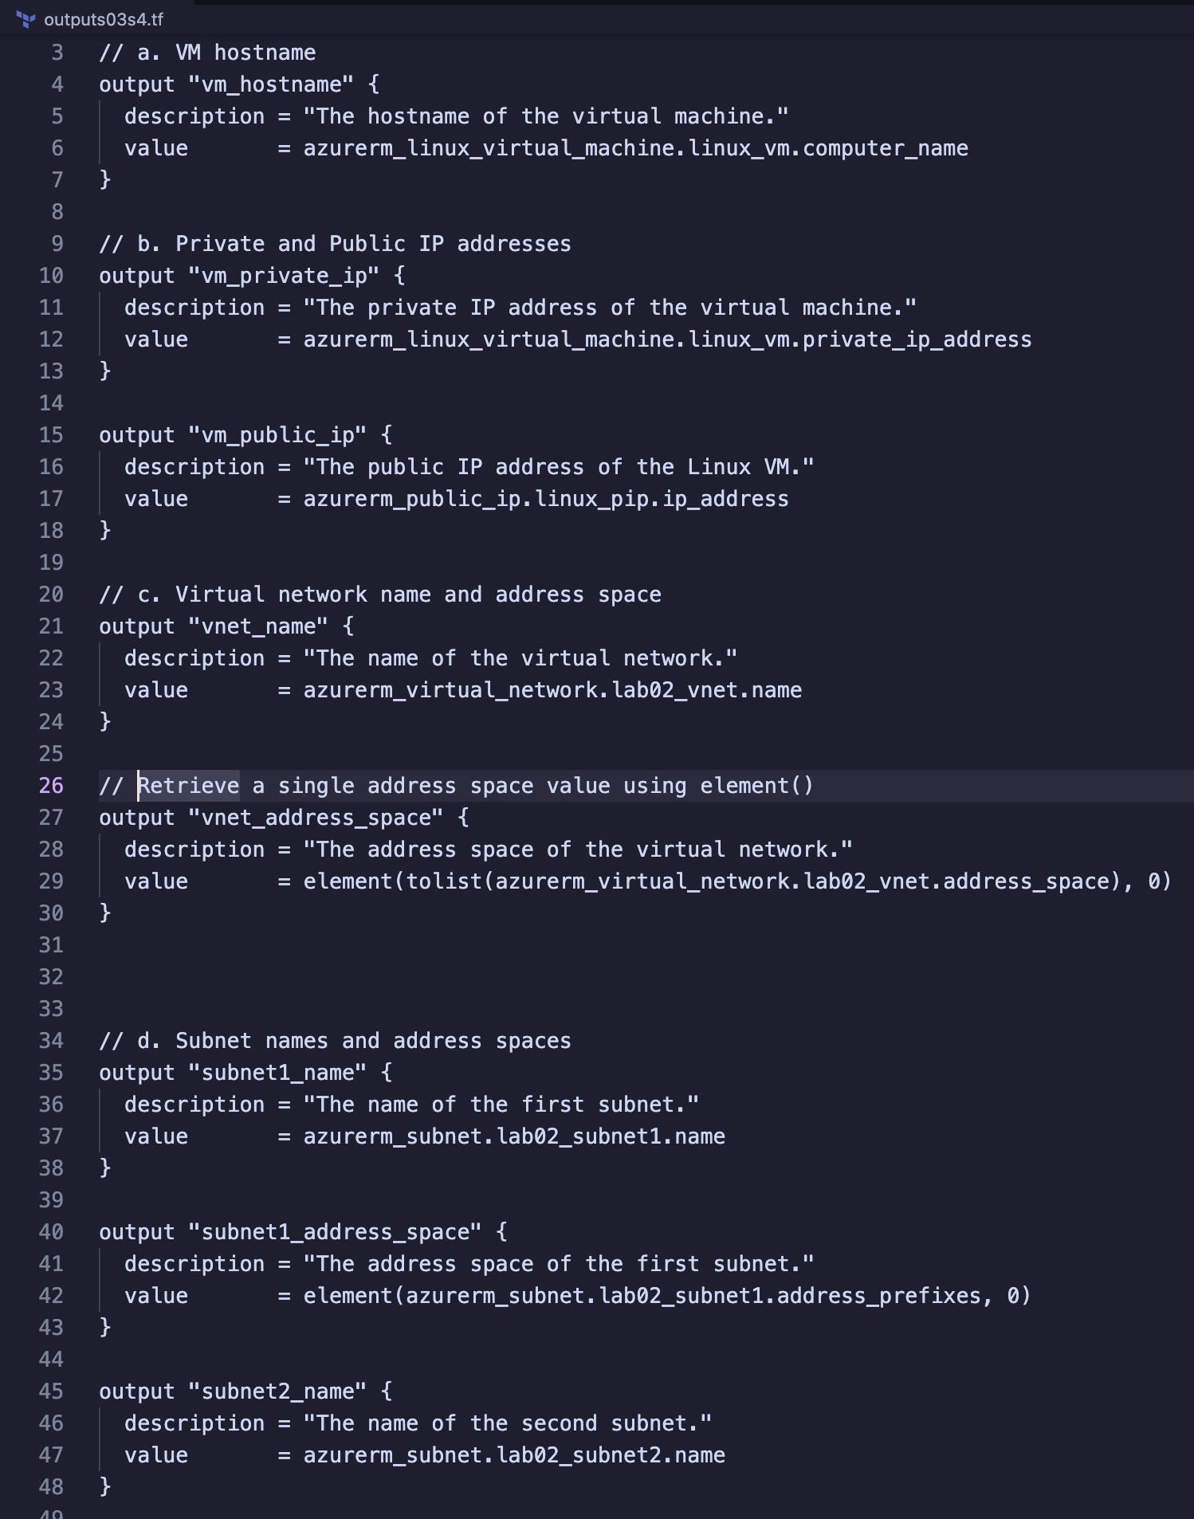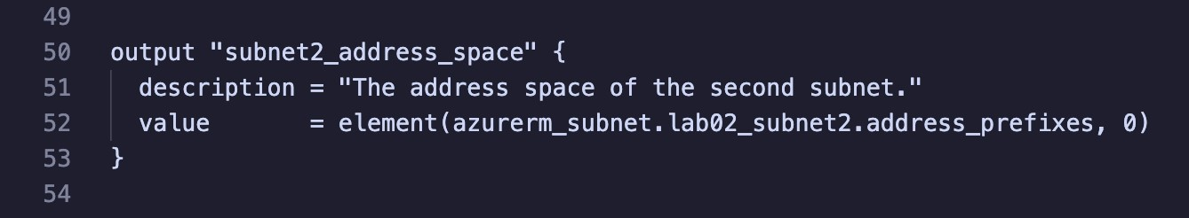

## Part 3: Validate Configuration

1. Validate the configuration to ensure no errors or typos:
2. Fix any issues in the Terraform files if reported.
3. Re-run validation until no errors are reported:

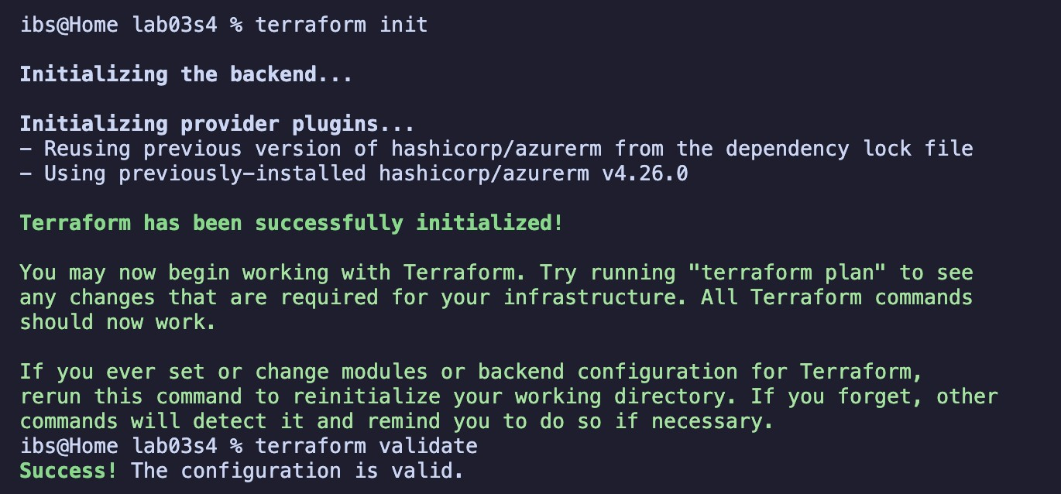

## Part 4: Run Simulation

1. Perform a dry run:

terraform plan

1. Review output and ensure all configuration meets requirements. Observe resources with +, -, or -/+ signs.
2. Fix any issues in the Terraform files if reported.
3. Redo the dry run until no errors are reported:

## Part 5: Deploy Infrastructure

1. Deploy the infrastructure and monitor progress:

terraform apply

o Type yes when prompted.

1. Confirm output values displayed on the screen at the end of deployment.

## Part 6: Get Information from Terraform State

14. View and analyze state information:

terraform state list terraform

show

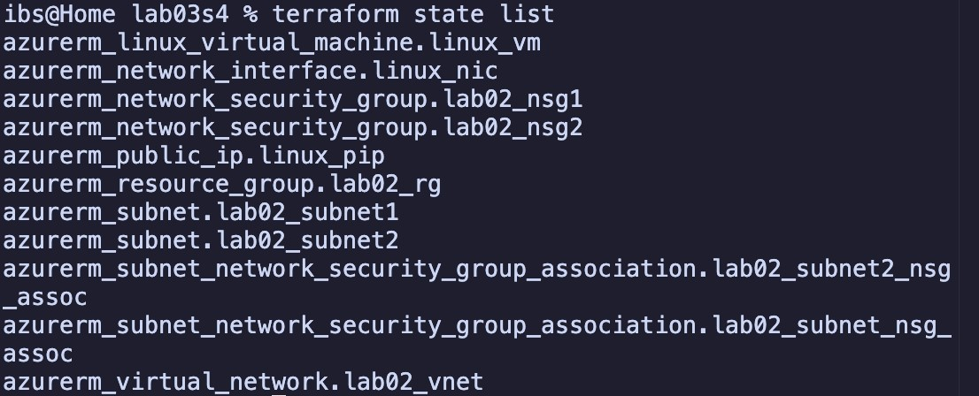

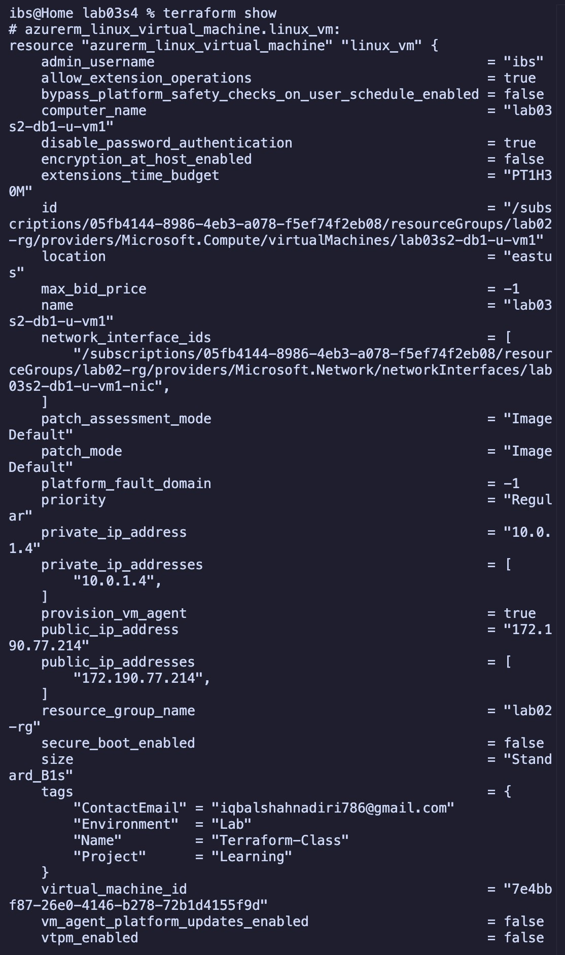

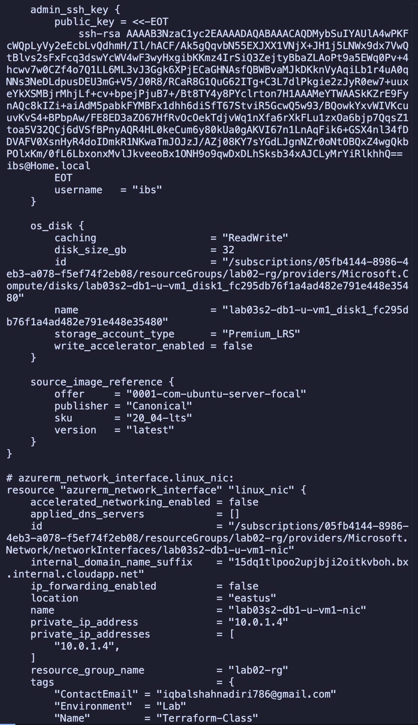

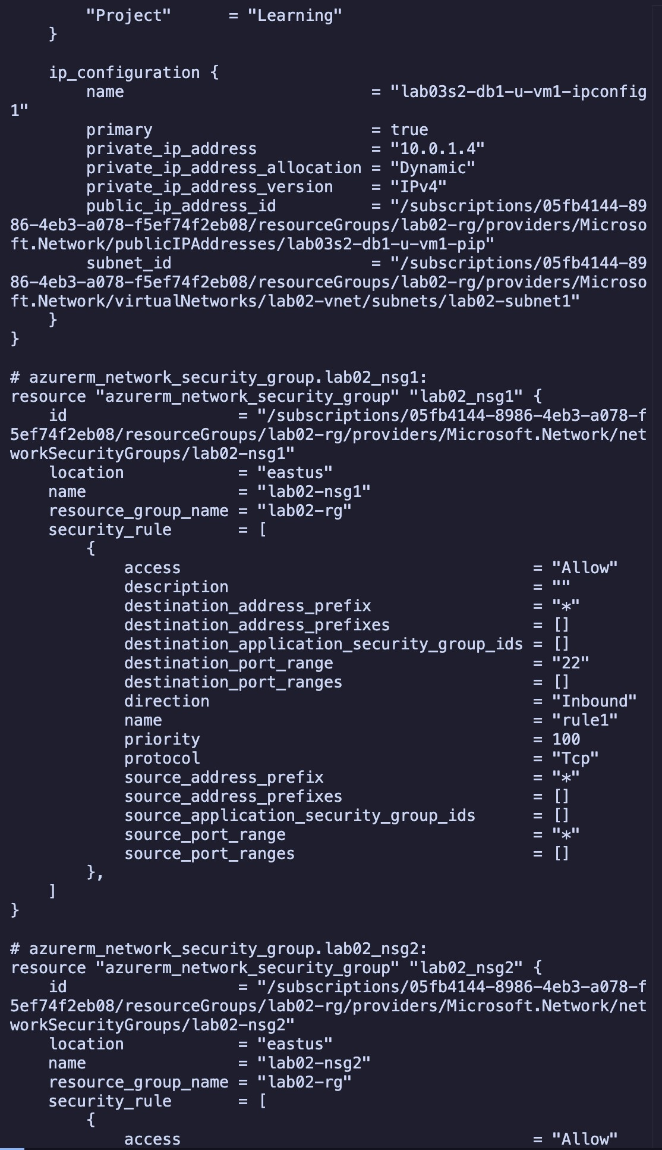

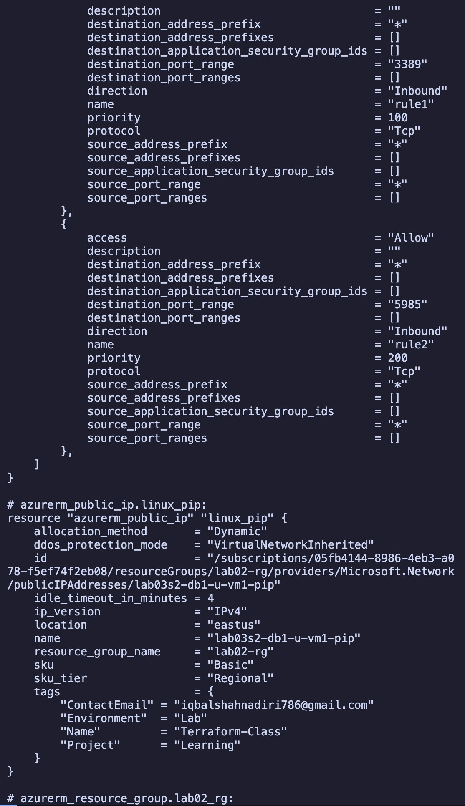

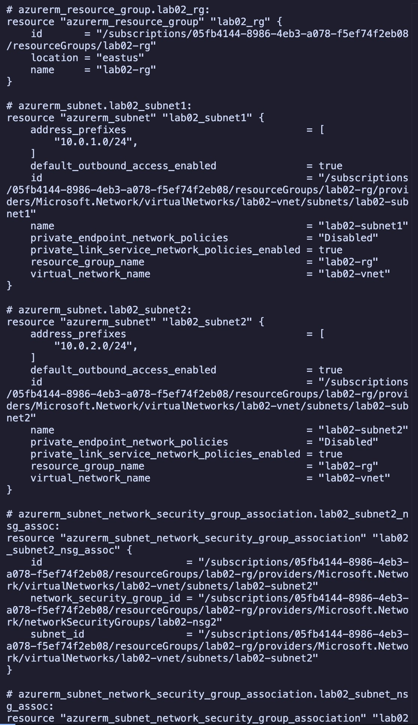

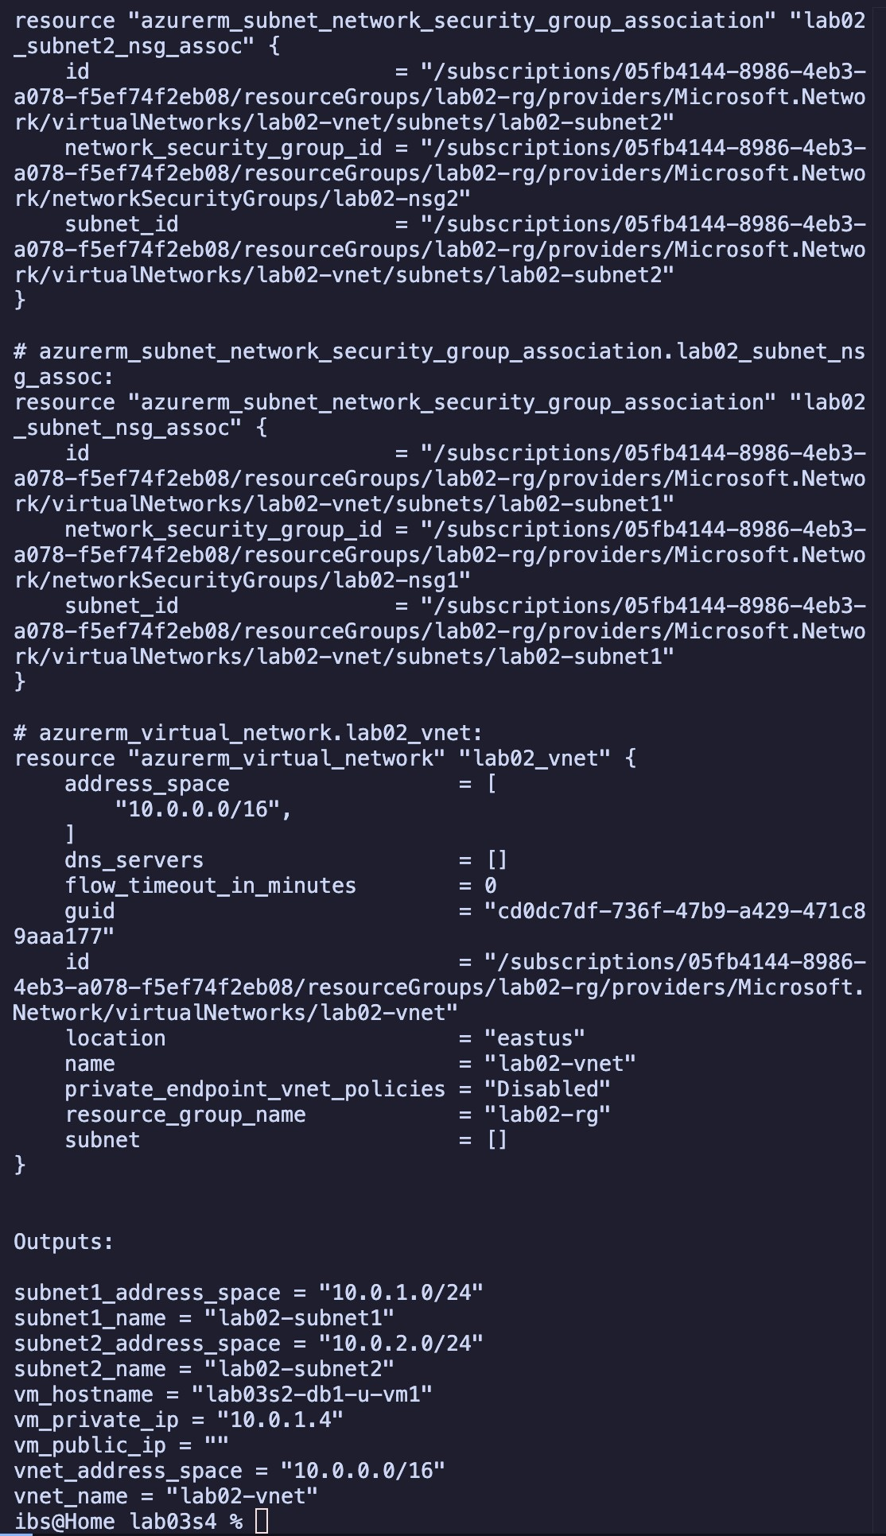

## Part 7: Display Output Information

15. Display output information:

terraform output

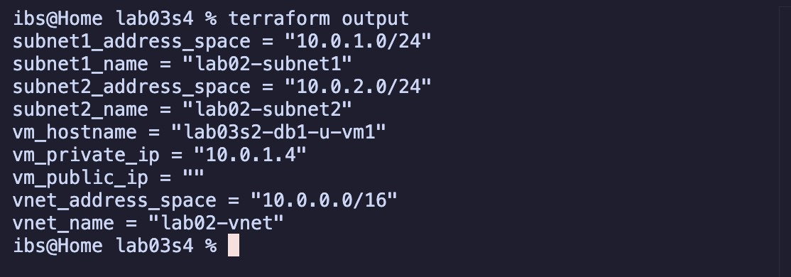

## Part 8: Destroy All Resources and Verify

1. Destroy all resources:

terraform destroy

o Type yes when prompted.

1. Verify deletion:

terraform state list terraform

show

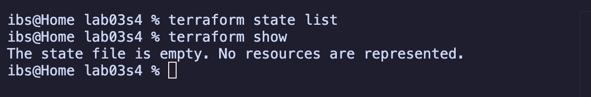

# Section 5

**Objectives:**

* Use configuration from Section 4.
* Define lifecycle rules to prevent updates and resource deletions.
* Define explicit dependency.
* Validate, deploy, expand, analyze, and destroy infrastructure.

## Part 1: Prepare for the Lab

1. Copy the lab03s4 directory as lab03s5:
2. Change into the lab03s5 directory:
3. Rename lab03s3.‘ as lab03s5.‘:

## Part 2: Update lab03s5.A File

4. Open lab03s5.‘ in a text editor and define an explicit dependency rule for the virtual machine to wait for the creation of the resource group.

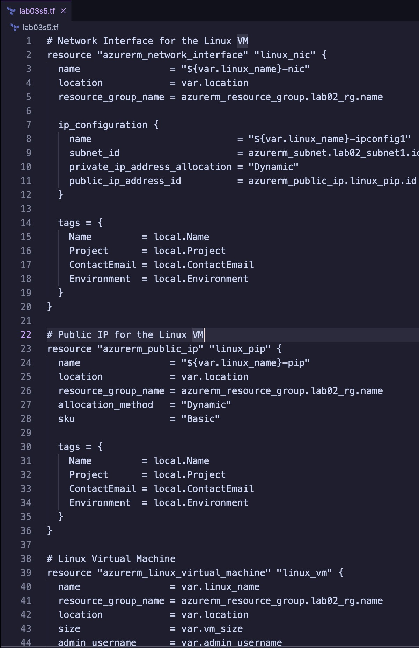

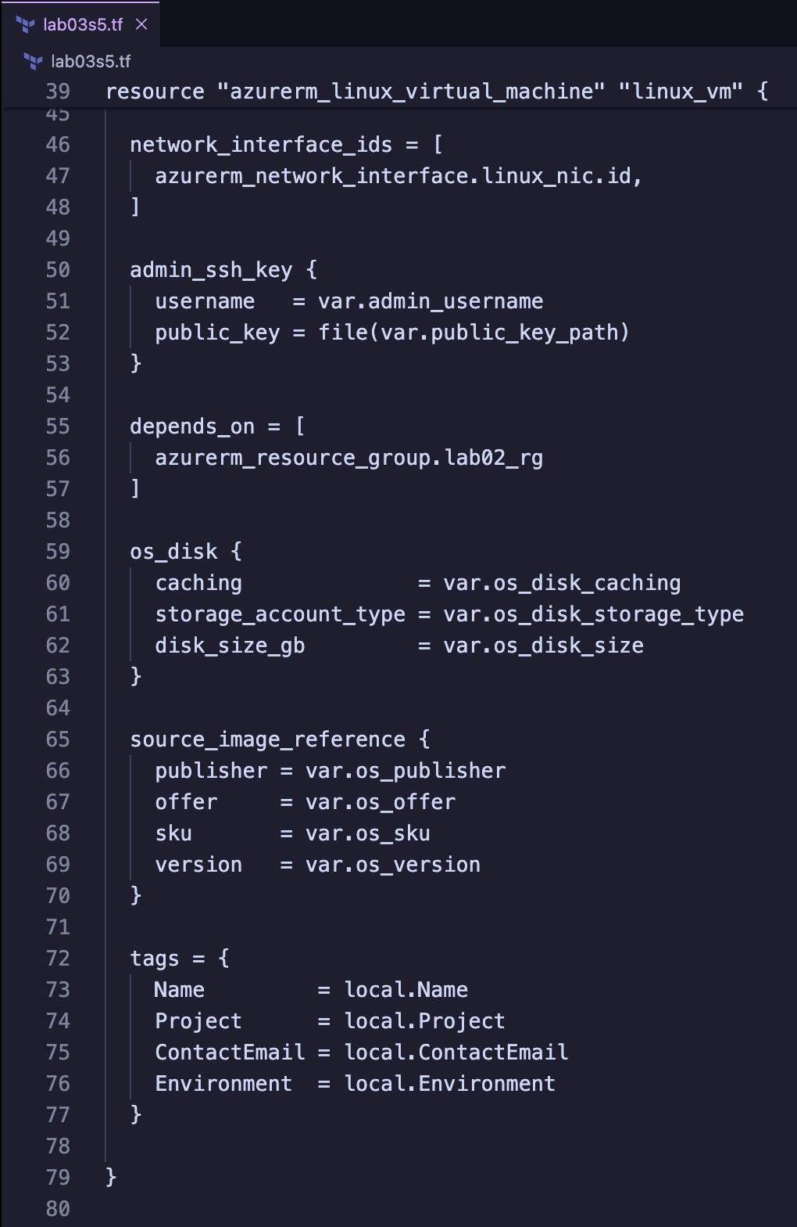

## Part 3: Validate Configuration

1. Validate the configuration to ensure no errors or typos:
2. Fix any issues in the Terraform files if reported.
3. Re-run validation until no errors are reported:

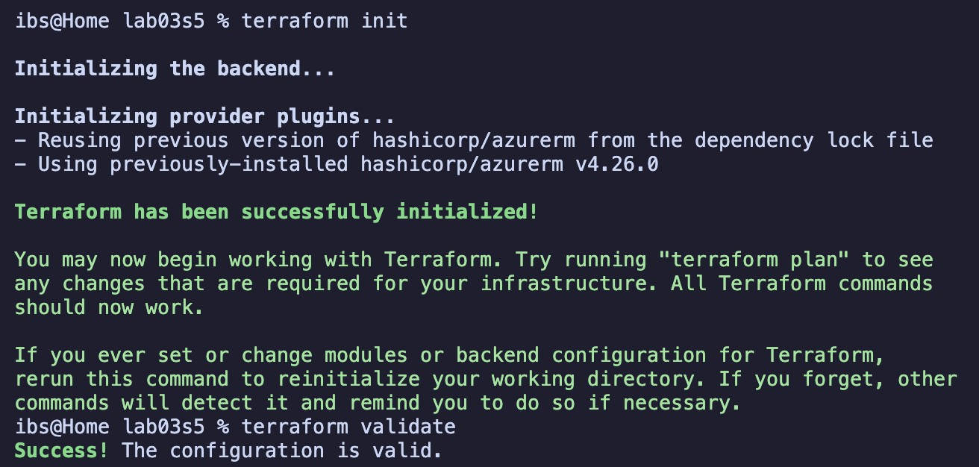

## Part 4: Run Simulation

1. Perform a dry run:

terraform plan

1. Review output and ensure all configuration meets requirements. Observe resources with +, -, or -/+ signs.
2. Fix any issues in the Terraform files if reported.
3. Redo the dry run until no errors are reported: **Part 5: Deploy Infrastructure**
4. Deploy the infrastructure and monitor progress:

terraform apply

o Type yes when prompted.

1. Confirm output values displayed on the screen at the end of deployment.

## Part 6: Add and Test a Lifecycle Deletion Rule

1. Edit lab03s5.‘ in a text editor and add a rule to prevent virtual machine, public IP, and network interface resources from removal (use lifecycle { prevent_destroy = true }).
2. Run:

terraform destroy

o Observe the error message generated.

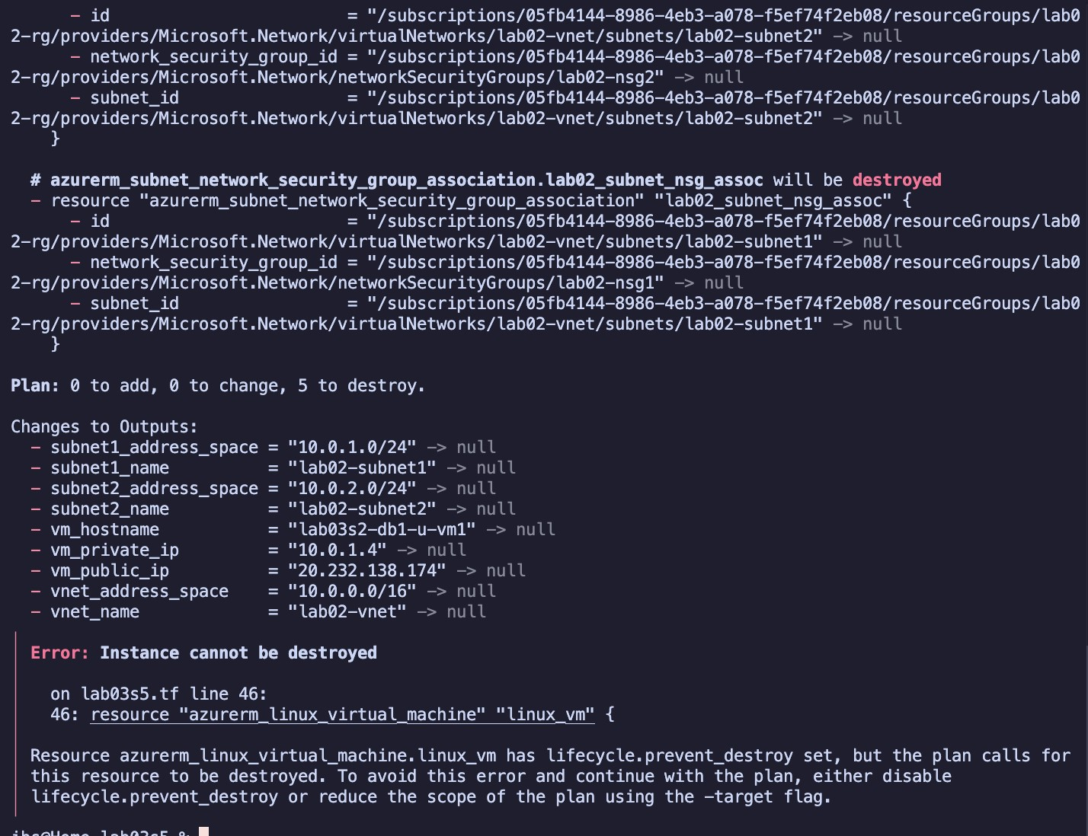

1. Edit lab03s5.‘ again and remove the deletion rules. *Do not destroy the infrastructure yet.*

## Part 7: Add and Test a Lifecycle Update Rule

1. Go to the Azure Portal and change some tag values for the virtual machine.
2. Edit lab03s5.‘ in a text editor and add a rule to prevent tag updates to the virtual machine (use lifecycle { ignore_changes = [tags] }).
3. Run:

terraform plan

o Observe the dry run output.

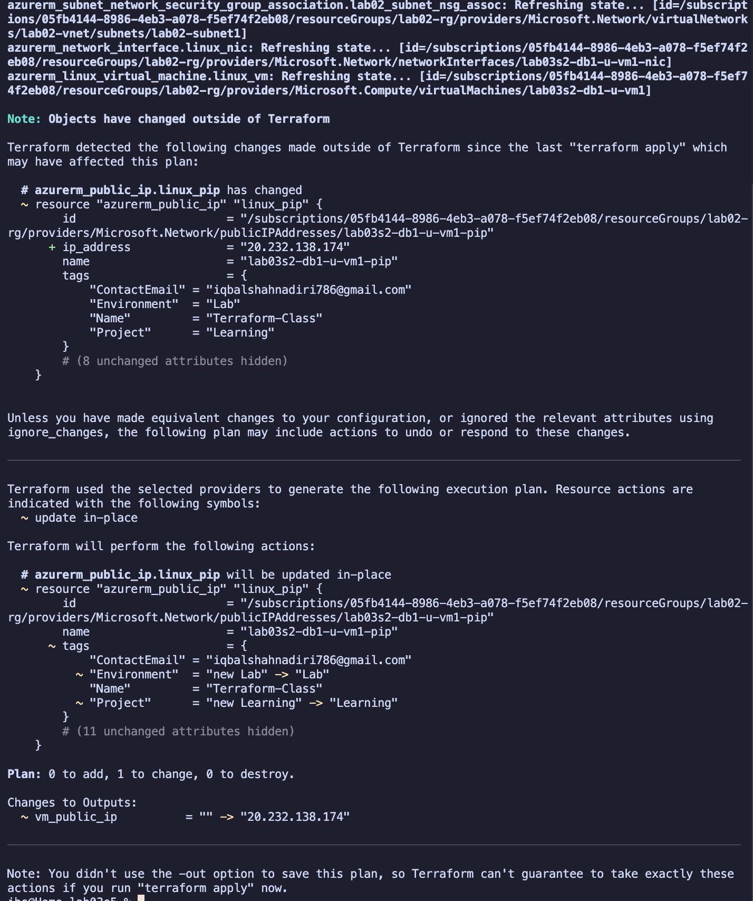

1. Edit lab03s5.‘ again and remove the update rule.

## Part 8: Display Dependency Graph

23. Show dependency tree:

terraform graph

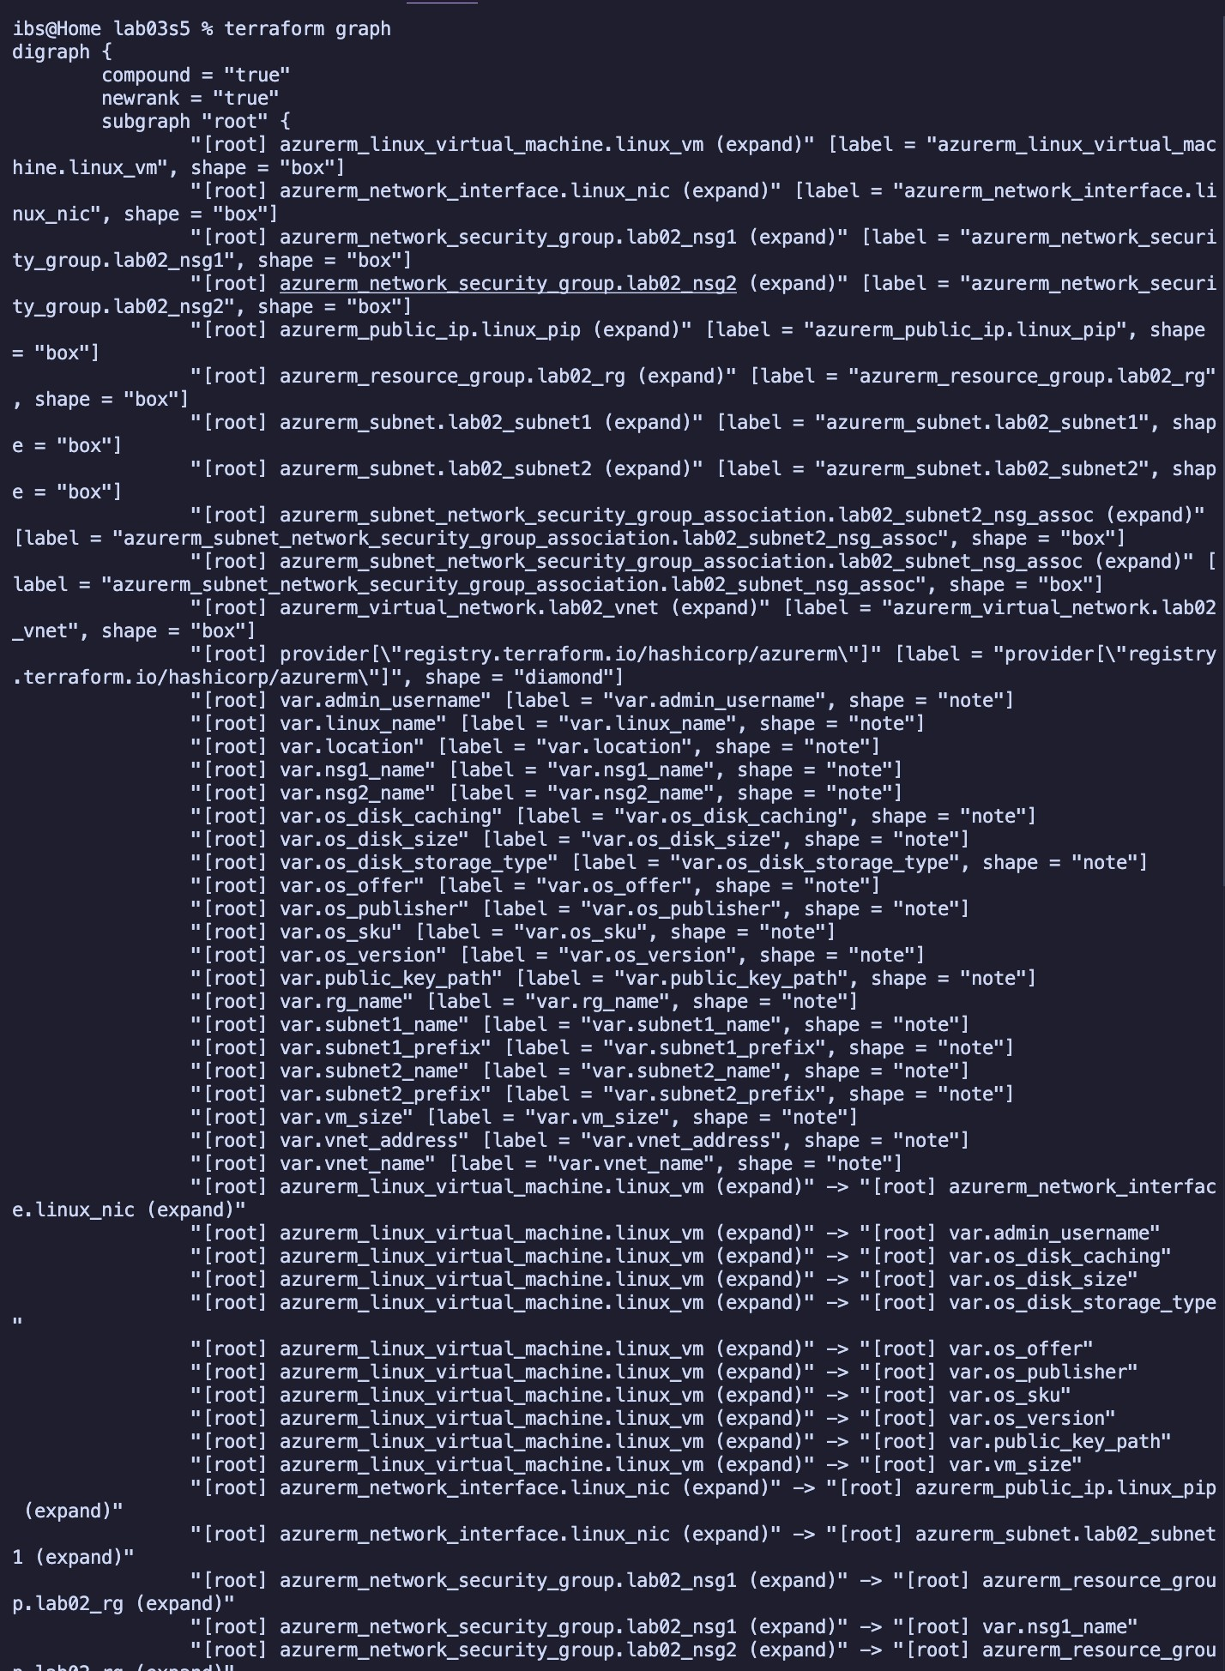

## Part 9: Destroy All Resources and Verify

1. Destroy all resources:

terraform destroy

o Type yes when prompted.

1. Verify deletion:

terraform state list terraform

show

